OIL RESIDUALS IN LOWLAND FOREST SOIL AFTER POLLUTION WITH CRUDE OIL

NIKOLA PERNAR^{1*}, DARKO BAKSIC¹, OLEG ANTONIC², MARIJAN GRUBESIC¹, IVICA TIKVIC¹, MLADEN TRUPCEVIC³
¹Department of Silviculture, Faculty of Forestry, University of Zagreb, 10000 Zagreb, Svetosimunska 25, Croatia; Laboratory of biocenotic research, Institute of Rugjer Boskovic, 10000 Zagreb, Bijenicka 54, Croatia; ³INA – Petrol Industry Ltd, Zagreb, Croatia;
(*author for correspondence, e-mail: pernar@hi.htnet.hr)

Abstract. Research on oil residuals in lowland forest soil was carried out in 6 sample plots in the lowland forest ecosystem located in an oil field. Four plots were differently affected in terms of discharged oil and the time lapsed after the accident, as well as in terms of micro-relief terrain features. One plot was established in a reclaimed mud ditch site, while the control plot was set up in a micro-relief elevation outside the influence of oil pollution.
Total petroleum hydrocarbon (TPH) concentrations were measured at three soil depths at the beginning and the end of the vegetation period. The analysis of the results revealed significant differences in petroleum hydrocarbon concentrations among the sites. Increased TPH concentrations were recorded in several plots, while the values measured in some other plots indicated very low quantities of residual TPH in the soil. The highest average TPH concentrations (200 – 400 mg kg⁻¹) were recorded in the mud ditch site. In one of the plots exposed to oil pollution after an oil pipe rupture, there was the constant presence of increased TPH concentration in the surface soil part (> 200 mg kg⁻¹on average). The sporadic presence of increased TPH concentrations in micro-depressions that cannot be attributed to a local accident indicates seasonal soil pollution with petroleum carbohydrates from floodwater.
The soil in the sample plots is not contaminated with soluble salts or heavy metals. Low values of TPH concentrations in the soil water eluate indicate that the soil does not represent a source of hydrospheric pollution with petrol hydrocarbons.
Key words: crude oil, floodplain forest, oil field, petroleum hydrocarbons, soil pollution

- Introduction

Petroleum is a complex, naturally occurring mixture of organic compounds, mostly relating to hydrocarbons. These compounds can have different forms: gaseous, often called natural gas, liquid crude oil, and solid or semisolid asphalt or tar.
Environmental accidents are generally related to crude oil. In the broadest sense, a drilling fluid ("wet oil") can be considered crude oil. It is transported to refineries after degassing and dehydration treatments ("dry oil").
Soil may be contaminated with crude oil in the drill point in the oil field or on the transport routes by which drilling fluid is brought to measuring stations and dehydration plants. In the oil fields of China the soil is contaminated by as much as 0.77 – 1.85% of crude oil (Xiong et al. 1997). In the past 20 or so years, in the oil field where this research was conducted, over 90% of the ruptures occurred in the pipelines transporting "wet oil". This testifies to the aggressive nature of drilling fluid (oil – water – acid gases), but also to the phenomenon commonly called pollution (Oldeman et al. 1991). Crude oils from different locations vary greatly in their hydrocarbon composition. The composition of drilling fluid depends on the share of gases and water. Differences occur in the concentrations of other substances that may have a damaging effect on the environment. Soil contaminated with organic substances often contains increased quantities of heavy metals, such as lead, mercury, arsenic and zinc (Roane and Kellogg 1996, Hirner et al. 2000). In such situations, microbiological diversity may be decreased, thus lessening the biodegradation potential of the microbe population (Diels et al. 1991, Burkhardt et al. 1993).
Soil functions as a chemical and biological filter that mitigates the effect of organic pollutants on the biosphere. This role is realised through sorption and through biological and chemical matter degradation (McBridge 1994). Chemical sorption is important for long-term retention of pollutants in the soil. Its reaction to oil pollution depends on the texture, chemism and microbiological properties (Sarkar et al. 2005). On the other hand, contaminated soil is a source of pollution for ground and surface water and consequently a potential contaminant of a wider area.
The impact of oil pollution is particularly complex in a forest ecosystem. It may lead to the decline of vegetation, which is directly reflected on the environmental and site value of a forest. Additional harm may be inflicted in the process of restoring an accident site: the soil may be compacted or the roots and the aboveground plant parts damaged. Mud ditches have a special status in an oil field. They were formerly used as disposal sites for drilling waste. Such sites are restored, but still represent points of threat in an oil field.
Redistribution of crude oil in space depends on its quantity, relief characteristics and soil properties. Oil fluid biodegradation depends on its quantity and properties. In the surface part of the soil, biodegradation takes place in predominantly aerobic conditions. In anaerobic conditions it is very slow (Casella and Payne 1996, Rieser-Roberts 1998). It has been proved that some oil components are resistant to anaerobic degradation (Alexander 1994).
A decrease in the quantity of petroleum hydrocarbons is particularly evident shortly after an accident (Berry and Burton, 1997, Chaineau 2003). Although such sites are immediately restored, the frequency of accidents and limitations in the restoration indicate the possibility of high petroleum hydrocarbon concentrations in the oil field soil. This imposes the need to analyse the condition of the sites in which the soil is exposed to oil pollution, especially in the case of valuable ecosystems.
The goal of this research was to characterise soil pollution by oil in the lowland forest ecosystem of an oil field. The choice of locations was governed by assumption of different intensity of pollution and time lapsed after an accident. The quantities and trends in the change of petroleum hydrocarbons (TPH) in the soil were determined by measurements of three years.

- Material and Method

  - Study site

Research was conducted in the oil field Žutica in central Croatia, situated in the area of a larger forest complex of the same name about 45 km southeast of Zagreb, in the marginal part of the Pannonian Plain (Figure 1). There are 275 wells in the field of which 165 are active. Initial exploration drilling began in the early 1960s. Production, started in 1966 and lasting to date, is based on the established system of oil and gas extraction and delivery facilities. The initial phase, when all the wells were eruptive, was followed by the current phase of suction pumps. Pipelines transport the drilling fluids to the measuring stations, where gas is separated and then delivered under the 4-5 bar pressure to the dehydration plant. Dehydrated fluid ("dry oil") is collected in delivery stations from where it is transported to refineries by the principal pipeline. The separated water is de-oiled and then injected back into the wells in order to sustain the pressure. Pipelines are made of welded seamless steel tubes, insulated with bitumen tape and placed in a trench at a depth of 80-110 cm. Over the years, the pipes are exposed to all kinds of corrosion, which is the principal reason for their rupture. More recently, pipes made of more resistant material (fibreglass) have gradually been installed.
The site is an undulating valley (94.3 – 101 m above the sea) with distinct micro-relief (local micro-elevations and micro-depressions with height differences of less than 1 m), subjected to regular floods. It is also used as an accumulation-retention area. Floods, generally occurring in April, may reach a height of 98.4 (Vrbek 1998).
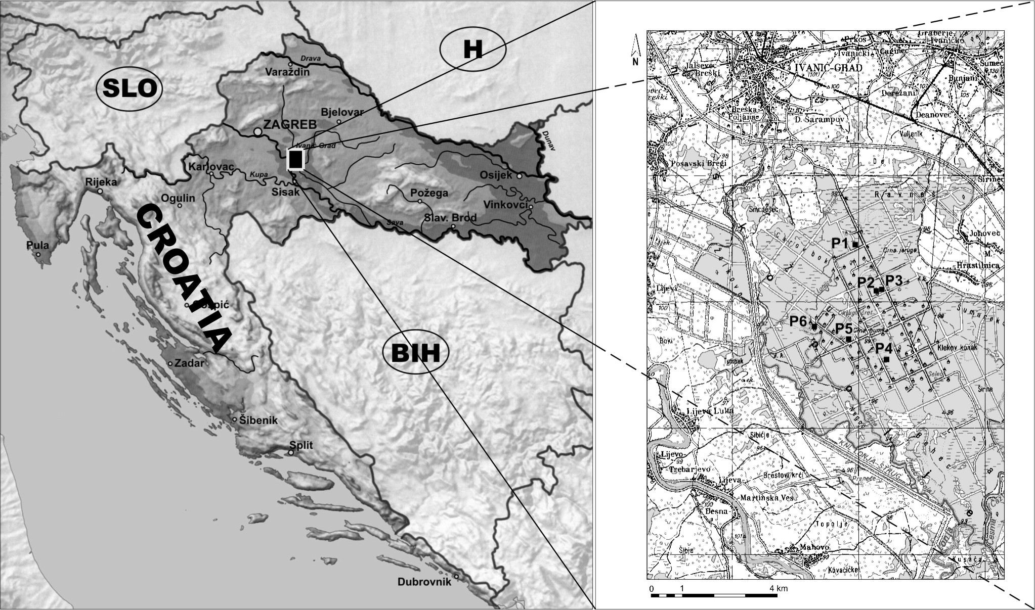
Figure 1. Geographical position of the study area and sample plot distribution.

The whole area of the forest Žutica is covered with Quaternary sediments including the sediments of old side channels (impure sand, silt and siltose clay), flood sediments (clayey and sandy silt), swampy sediments (clay and clayey silt), terrace sediments (silt, sand and gravel).
The structure of the pedosphere is characterised by alternating hydromorphous soils. These are generally planosol and gleysol, and to a lesser extent fluvisol, deposol, dy and sapropel (Vrbek 1998).
Climatologically, this area is characterised by the mean annual air temperature of about 11 °C, while the mean annual precipitation varies from 800 to 1,100 mm.
The dominant tree species is pedunculate oak (Quercus robur L.), which is the edifier in several forest communities, either in combination with common hornbeam (Carpinus betulus L.) or narrow-leaved ash (Fraxinus angustifolia Vahl.). The lowest positions are occupied by black alder (Alnus glutinosa (L.) Gaertn.), whereas willow forests occur along watercourses and channels. Intensive anthropogenic and technogenic activities in this area (a dense road network, oil extraction and transportation plants, accidents and oil pollution) have had an immense impact on synecological relationships in the forest ecosystem (Bašić et al. 1993). There is sporadic dieback of individual trees and shrubs, as well as the decline of the ground vegetation. Physiological weakening of the trees and a disturbed stability of the ecosystem are attributed to the slow retreat of floodwater induced by a dense road network (Vrbek 1998), and are also attributed to pollution with crude oil.

2.1.1. Forest plots, accident characteristics, reclamation techniques, mud ditch

Field research was organised in 6 sample plots (Fig 1). The pipeline fractures and crude oil spills into the soil occurred in four sample plots (Table I). One sample plot was established in the site of a restored mud ditch, while the control plot was set up in the raised part of the terrain outside the reach of crude oil pollution.

TABLE I
Some pollution characteristics in different sites.
Sample plot | Location | Contamination description / fluid quantity | Fluid properties | Time of accident /reclamation
P1 | Colector 9 | 0,3-0,5 m³  0,3-0,5 m³ | 99% of water with pH 8,5 and 12,9 g NaCl/l | 2000. i 2003.
P2 | 254 | mud ditch |  | 1996.
P3 | Pressure line | 300 m³ | 50% water with pH 8,0 and 12,5 g NaCl/l | 1985.
P4 | M8-211 | 1 m³ | 90%water with pH 8,5 and 12,5 g NaCl/l | 2001.
P5 | 225 | 3 m³ | 72% water with pH 8 and 13,5 g NaCl/l | 1999.
P6 | 191 | control | - | -

After the accident, the terrain was reclaimed by digging out and removing the polluted soil, repairing the pipe and bringing clean soil mixed with sand and quick lime. Except for the differences in the pollutant quantity, differences in its content were also evident (Table I), which might reflect on the nature of pollution.

  - Soil sampling

Soil sampling was conducted in 25 x 25m plots (6 plots). The 25-point network was placed within each plot in a plot distribution of 5x5 m (Figure 2). In each of the plots, soils from the depths of 0-10 (a), 30-50 (b) and 70-100 (c) cm were sampled. Three composite samples were formed per plot, each obtained by mixing 25 individual samples. Sampling was performed at the end of April and at the end of October, or in other words, at the beginning and the end of the vegetation period. Total TPH contents were measured during three years (2003, 2004 and 2005), with 6 sample series in all (Figure 2). The following was determined in the first series of composite soil samples: texture, pH values, organic carbon (OC) content, TPH content in the soil water eluate, electroconductivity (EC) and heavy metal (HM) content.
A pedological profile was dug next to each plot, where individual samples per horizons were taken to determine general soil characteristics (pH, OC, total nitrogen, texture, carbonate content).
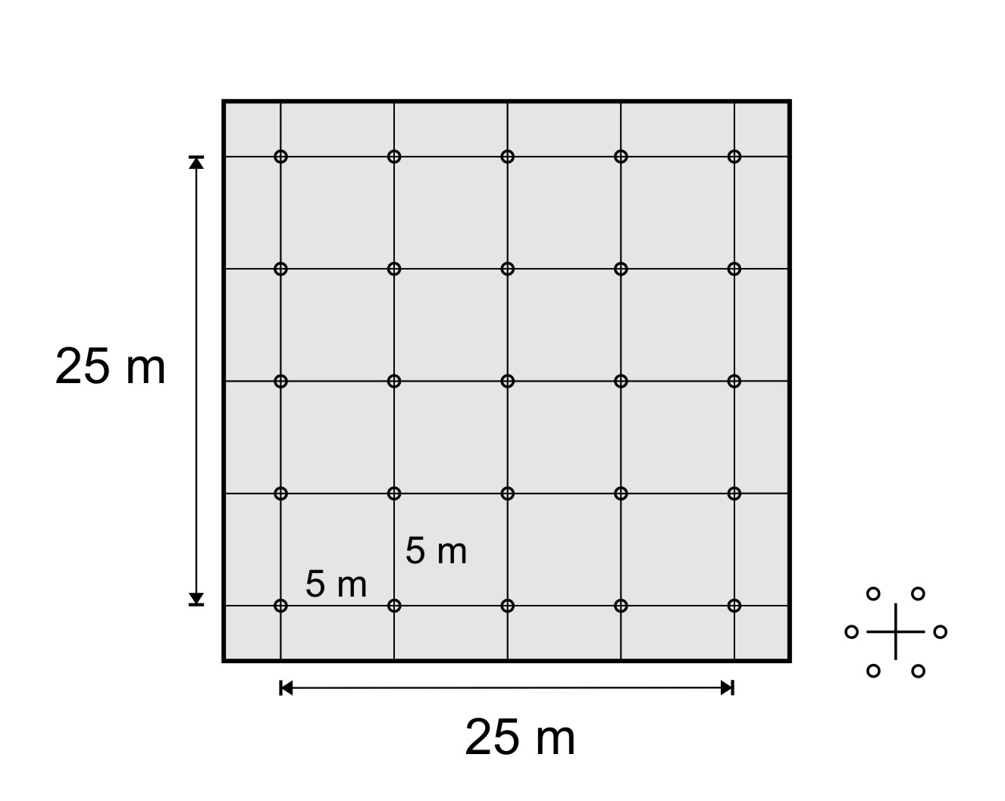
Figure 2. Soil sampling in the plots.

2.3. Soil analysis

TPH in the soil was measured according to the DIN 38 409 H18 method. After extraction with tetrachlormethane, the CH₃₋ and CH₂₋ groups of diesel oil were quantitatively determined with an infrared spectrometer. TPH in the water eluate was determined using the same method after shaking the suspended soil in distilled water for 24 hours. Heavy metals were determined in accordance with the ISO 11466 Norm using ICP-AES and AAS (ISO 11047). EC was determined according to the 11265 ISO Norm.
The pH value was determined according to the 10390 ISO Norm, while organic carbon (OC) was determined using the bichromatic method (Tjurin) and nitrogen using the modified Kjehldal's method (ISO 11261). The carbonate content was determined according to the 10693 ISO Norm, whereas particle size distribution (texture) was determined according to the modified 11277 ISO Norm.
  - Statistical analysis

Soil concentrations of TPH measured in six different sample plots (and at three soil depths in each plot) were compared with non-parametric statistical tests of dependent samples, appropriate for this research due to the time dependency of the samples. The Wilcoxon test and Sign test (Ott, 1993) were used to compare particular pairs of sample populations relevant for this research, including: 1) comparison of different soil depths in the same plot (within-plot comparison), and 2) comparison of particular soil depths in the control plot with the respective soil depths in the polluted plots (between-plot comparison).

- Results

  - Soil description

Gleysol occurs in all the four plots affected by crude oil from the pipeline (Table II): deposol is found in the mud ditch site, while planosol occurs in the control plot. According to research, gleysols are carbonate in the deeper parts of the profile or in the entire profile, deposol is carbonate across the profile, and planosol is non-carbonate. The texturally heaviest soil occurs in plot 1 and the lightest in plot 3 and plot 6. Sand was introduced in plot 3 during the reclamation activities, which is reflected on the texture of the surface part of the soil. Solidified fragments of mud mass and lime were found at a depth below 50 cm in plot 2. The organic carbon content in the humus-accumulative horizon is 25 – 49 g kg⁻¹, except in plot 2, where its distribution in the profile indicates an unnatural state of the soil (deposol). The total nitrogen content corresponds with the organic carbon content. It reaches the highest values (3.76 g kg⁻¹) in the surface horizon in plots 4 and 6.
The presence of carbonates is the cause of alkaline reaction in the carbonate part of the profile. In plot 2, the whole profile has an alkaline reaction due to the use of lime in mud ditch restoration. The reaction of planosol in plot 6 is very acid to acid across the whole profile.
The results of composite soil sample analysis (Table III) show somewhat different relations among the plots in terms of texture, pH values and organic carbon content. The composite sample analysis indicates that planosol in plot 6 is carbonate at a depth of 70 – 100 cm. The total carbon content in deposol in plot 2 is more or less equal at all three sampling depths, while an increased coarse sand content in plots 2 and 3 indicates its introduction during the mud ditch restoration, or the restoration of the accident site after a major oil spill.

TABLE II
Soil description in the profiles next to the plots.
Sample plot | Soil | Horizon |  |  | pH |  | C org. | N total | Carbonate (CaCO₃) | Particle size distribution (%)
Sample plot | Soil | Sign | Upper border | Down border | in water | 0,01 M CaCl₂ | g kg⁻¹ |  |  | Coarse sand | Fine sand | Silt | Clay
P1 | Gleysol | Aa | 0 | 15 | 5,93 | 5,86 | 31,5 | 2,63 | 0 | 0,7 | 28,5 | 29,1 | 41,7
P1 | Gleysol | Gsor | 16 | 40 | 6,17 | 5,36 | 10,3 | 1,64 | 0 | 0,2 | 25,2 | 25,9 | 48,7
P1 | Gleysol | Gr | 41 | 80 | 6,49 | 5,86 | 3,3 | 0,79 | 0 | 0,2 | 31,5 | 25,9 | 42,4
P1 | Gleysol | Grso | 81 | 105 | 7,26 | 6,62 | 2,4 | 0,65 | 29,8 | 0,8 | 35,7 | 33,4 | 30,1
P1 | Gleysol | Grsoca | 106 | 140 | 8,10 | 7,51 | 2,1 | 0,23 | 136,2 | 1,5 | 23,5 | 41,0 | 34,0
P2 | Deposol | I | 0 | 25 | 7,77 | 7,36 | 4,2 | 0,65 | 21,3 | 1,1 | 39,4 | 33,5 | 26,0
P2 | Deposol | II | 26 | 45 | 7,70 | 7,32 | 18,6 | 1,92 | 55,3 | 4,3 | 36,9 | 29,7 | 29,1
P2 | Deposol | III(Gso) | 46 | 62 | 7,84 | 7,32 | 4,2 | 0,79 | 25,5 | 0,5 | 37,1 | 34,6 | 27,8
P2 | Deposol | IV(Gr) | 63 | 100 | 7,51 | 7,08 | 4,2 | 0,37 | 38,3 | 0,6 | 41,0 | 29,8 | 28,6
P3 | Gleysol | Aa | 0 | 14 | 6,73 | 6,65 | 41,9 | 3,91 | 29,8 | 8,4 | 42,7 | 29,6 | 19,3
P3 | Gleysol | Gr1 | 15 | 45 | 7,35 | 6,73 | 4,2 | 0,93 | 46,8 | 0,5 | 41,4 | 30,8 | 27,3
P3 | Gleysol | Grso | 46 | 82 | 7,62 | 7,04 | 2,4 | 0,65 | 25,5 | 0,2 | 43,6 | 31,3 | 24,9
P3 | Gleysol | Gso | 83 | 100 | 8,13 | 7,29 | 2,6 | 0,65 | 38,3 | 0,6 | 31,7 | 36,7 | 31,0
P3 | Gleysol | Gr2 | 101 | 150 | 8,26 | 7,42 | 3,7 | 1,36 | 80,9 | 0,3 | 36,1 | 33,7 | 29,9
P4 | Gleysol | Aa | 0 | 10 | 6,52 | 5,86 | 49,2 | 3,76 | 25,5 | 2,2 | 41,7 | 35,0 | 21,1
P4 | Gleysol | Grso | 11 | 50 | 6,62 | 5,85 | 5,9 | 2,21 | 27,7 | 0,9 | 38,0 | 29,5 | 31,6
P4 | Gleysol | Gsor | 51 | 130 | 6,95 | 6,24 | 1,6 | 0,65 | 40,4 | 0,8 | 26,5 | 39,1 | 33,6
P4 | Gleysol | Gr | 131 | 150 | 8,20 | 7,30 | 5,0 | 0,79 | 93,7 | 0,8 | 35,7 | 31,2 | 32,3
P5 | Gleysol | Aa | 0 | 10 | 5,65 | 4,73 | 24,9 | 1,78 | 0 | 0,5 | 36,4 | 36,8 | 26,3
P5 | Gleysol | Grso1 | 11 | 55 | 6,40 | 5,24 | 7,1 | 1,22 | 0 | 0,2 | 33,9 | 31,9 | 34,0
P5 | Gleysol | Gr | 56 | 80 | 7,67 | 7,07 | 5,7 | 0,93 | 38,3 | 0,0 | 38,4 | 30,5 | 31,1
P5 | Gleysol | Gso | 81 | 98 | 7,95 | 7,49 | 1,6 | 0,65 | 63,9 | 0,6 | 37,3 | 32,3 | 29,8
P5 | Gleysol | Grso2 | 99 | 120 | 7,84 | 7,45 | 2,3 | 0,37 | 68,1 | 0,2 | 38,8 | 32,4 | 28,6
P5 | Gleysol | Gsor | 121 | 150 | 7,67 | 7,35 | 1,0 | 0,23 | 34,1 | 0,5 | 48,4 | 26,6 | 24,5
P6 | Planosol | Aoh | 0 | 8 | 4,83 | 4,00 | 26,8 | 3,76 | 0 | 1,3 | 50,6 | 30,9 | 17,2
P6 | Planosol | Eg | 9 | 25 | 4,92 | 4,09 | 6,4 | 1,22 | 0 | 0,9 | 50,4 | 30,1 | 18,6
P6 | Planosol | BgI | 26 | 55 | 5,65 | 4,59 | 1,9 | 0,23 | 0 | 0,4 | 46,0 | 28,2 | 25,4
P6 | Planosol | BgII | 56 | 150 | 5,43 | 4,33 | 0,9 | 0,08 | 0 | 0,1 | 63,7 | 16,7 | 19,5

TABLE III
General physiographic soil properties according to the composite samples taken from the plots. Bold numbers indicate plots, and the related characters indicate soil depths (a: 0-10cm, b: 30-50cm, c: 70-100 cm).
Sample plot | Sample | pH |  | C org. | Particle size distribution (%)
Sample plot | Sample | in water | 0,01 M CaCl₂ | g kg⁻¹ | Coarse sand | Fine sand | Silt | Clay
P1 | 1a | 6,05 | 5,51 | 33,9 | 1,3 | 28,7 | 33,2 | 36,8
P1 | 1b | 6,08 | 5,48 | 7,3 | 0,1 | 29,2 | 27,3 | 43,4
P1 | 1c | 7,32 | 7,09 | 2,3 | 0,5 | 39,2 | 28,2 | 32,1
P2 | 2a | 8,17 | 7,78 | 14,8 | 23,3 | 39,1 | 18,3 | 19,3
P2 | 2b | 9,11 | 8,64 | 12,2 | 9,2 | 39,2 | 26,1 | 25,5
P2 | 2c | 8,62 | 8,04 | 10,8 | 3,7 | 36,4 | 29,6 | 30,3
P3 | 3a | 7,46 | 6,75 | 23,1 | 34,1 | 35,9 | 15,3 | 14,7
P3 | 3b | 7,24 | 7,07 | 6,6 | 1,2 | 41,0 | 32,1 | 25,7
P3 | 3c | 7,85 | 7,35 | 1,7 | 1,3 | 40,1 | 33,2 | 25,4
P4 | 4a | 6,32 | 6,18 | 28,7 | 6,6 | 44,7 | 31,2 | 17,5
P4 | 4b | 6,39 | 5,96 | 4,3 | 1,1 | 38,9 | 31,4 | 28,6
P4 | 4c | 7,15 | 6,64 | 2,1 | 0,5 | 43,4 | 28,8 | 27,3
P5 | 5a | 5,50 | 4,95 | 19,7 | 0,6 | 39,6 | 33,4 | 26,4
P5 | 5b | 5,61 | 5,05 | 4,9 | 0,3 | 34,0 | 34,8 | 30,9
P5 | 5c | 6,98 | 6,21 | 2,4 | 0,2 | 33,6 | 31,2 | 35,0
P6 | 6a | 5,15 | 4,51 | 20,2 | 1,0 | 50,5 | 24,6 | 23,9
P6 | 6b | 5,31 | 4,50 | 3,3 | 0,3 | 50,9 | 20,0 | 28,8
P6 | 6c | 7,76 | 7,33 | 1,9 | 0,2 | 54,4 | 21,1 | 24,3

3.2 Heavy metals in the soil, electroconductivity and water eluate in the soil

Any analysis of soil contamination with crude oil and oil derivatives regularly involves heavy metal and petroleum hydrocarbon determination in the soil (Adeniyi and Afolabi 2002), whose negative impacts are reflected in the biological processes catalysed by micro-organisms. These include reducing the density of bacterial populations, inhibiting decomposition and mineralisation of organic substances and decreasing the degree of site mycorrhization (Koomen et al. 1990, Chander et al, 1991, Roane and Kellogg 1996).
The composition of drilling fluids from the 2003 accidents in several localities outside the plots (Table IV) indicates the possibility of soil salinization in the oil field area.
Accordingly, soil analysis was conducted on the first series of composite samples with regard to heavy metals and electroconductivity (Table V). The results did not show increased concentrations of heavy metals in any of the affected plots. Low electroconductivity indicates the absence of increased salt concentrations in the soil.

TABLE IV
Drilling fluid content that spilled in the environment in 2003 after the rapture of the pipeline in the oil field. (Data were obtained from the INA Ecological Service, which manages the Žutica oil field).
Date of accident | Fluid quantity (l) | % of water | Water salinity (g l⁻¹)
09.01.2003. | 200 | 86 | 12,9
24.03.2003. | 50 | 90 | 9,0
28.07.2003. | 200 | 66 | 19,8

TABLE V
Oil residuals in water eluate, electroconductivity and heavy metals in the soil of the sample plots. (Bold numbers indicate plots, and the related characters indicate soil depths (a: 0-10cm, b: 30-50cm, c: 70-100 cm).
Sample plot | Sample | TPH | Electroconductivity | Fe | Mn | Cu | Zn | Ni | Cr | Pb | Cd | Co
Sample plot | Sample | mg/dm³ | dS m⁻¹ | mg/kg⁻¹
P1 | 1a | 5,700 | 0,199 | 15083 | 99,5 | 13,7 | 55 | 14,9 | 22,9 | 18,8 | <0,25 | 5,1
P1 | 1b | 0,348 | 0,098 | 21714 | 75,4 | 16,1 | 60 | 18,5 | 28,4 | 14,1 | <0,25 | 6,8
P1 | 1c | 0,814 | 0,311 | 20960 | 575,4 | 24,7 | 56 | 31,2 | 26,2 | 10,2 | <0,25 | 12,4
P2 | 2a | 2,150 | 0,193 | 15250 | 224,2 | 17,3 | 46 | 15,8 | 15,9 | 10,9 | <0,25 | 6,2
P2 | 2b | 0,456 | 0,272 | 14291 | 237,4 | 15,2 | 39 | 14,5 | 15,2 | 9,3 | <0,25 | 5,6
P2 | 2c | 0,239 | 0,262 | 17279 | 200,8 | 17,7 | 36 | 14,4 | 15,1 | 10,2 | <0,25 | 5,9
P3 | 3a | 0,240 | 0,236 | 7982 | 131,1 | 7,4 | 56 | 5,8 | 7,9 | 14,8 | <0,25 | 2,1
P3 | 3b | 0,073 | 0,157 | 13362 | 235,4 | 7,5 | 32 | 8,5 | 10,6 | 10,9 | <0,25 | 3,8
P3 | 3c | 0,456 | 0,256 | 17314 | 289,3 | 19,6 | 35 | 16,1 | 13,6 | 10,6 | <0,25 | 5,9
P4 | 4a | 0,239 | 0,301 | 11530 | 161,2 | 7,7 | 54 | 14,4 | 18,7 | 14,1 | <0,25 | 6,2
P4 | 4b | 0,086 | 0,136 | 22141 | 686,1 | 15,6 | 72 | 25,2 | 30,4 | 9,3 | <0,25 | 17,4
P4 | 4c | 0,247 | 0,194 | 25761 | 702,8 | 29,1 | 70 | 39,7 | 34,6 | 10,3 | <0,25 | 15,9
P5 | 5a | 0,090 | 0,116 | 15375 | 176,4 | 10,2 | 51 | 17,2 | 21,2 | 17,3 | <0,25 | 6,8
P5 | 5b | 0,215 | 0,058 | 16982 | 149,7 | 12,4 | 51 | 20,1 | 24,4 | 12,5 | <0,25 | 8,9
P5 | 5c | 0,375 | 0,225 | 24812 | 287,5 | 29,9 | 64 | 41,4 | 32,3 | 11,7 | <0,25 | 16,3
P6 | 6a | 0,093 | 0,122 | 16191 | 307,9 | 14,8 | 50 | 21,6 | 19,7 | 15,6 | <0,25 | 9,8
P6 | 6b | 0,136 | 0,049 | 18453 | 253,4 | 17,7 | 52 | 24,1 | 22,7 | 10,9 | <0,25 | 10,6
P6 | 6c | 0,216 | 0,220 | 19203 | 343,5 | 22,3 | 53 | 29,7 | 24,2 | 7,8 | <0,25 | 12,9

Due to the constant release of pollutants in the soil solution, the polluted soil is a potential source of ground and surface water pollution. Measurements of mineral oil content in the water eluate after soil eluation (Table V) show increased concentrations only in the shallowest layer (a) in plot 1 (fluid spill in 2003, two months prior to soil sampling) and in plot 2 (mud ditch). In plot 1 accident in March 2003 is characterised by small quantities of released fluid. It was partly redistributed by floodwater to a larger area and sorbed in the clayey, surface part of the soil.

  - Total petrol hydrocarbons

The soil at all three depths in plot 2 (reclaimed mud ditch site) is still polluted with crude oil, but at the level of weak to medium contamination (Toti et al. 1998). Concentrations increase with depths, but with no significant difference between the second and the third layer (Table VI). The values are significantly higher for all three layers than in the control plot (Table VII). The result in the c layer is highly variable, which might be attributed to the impact of solidified material (skeleton), which caused difficulties in sampling as well.
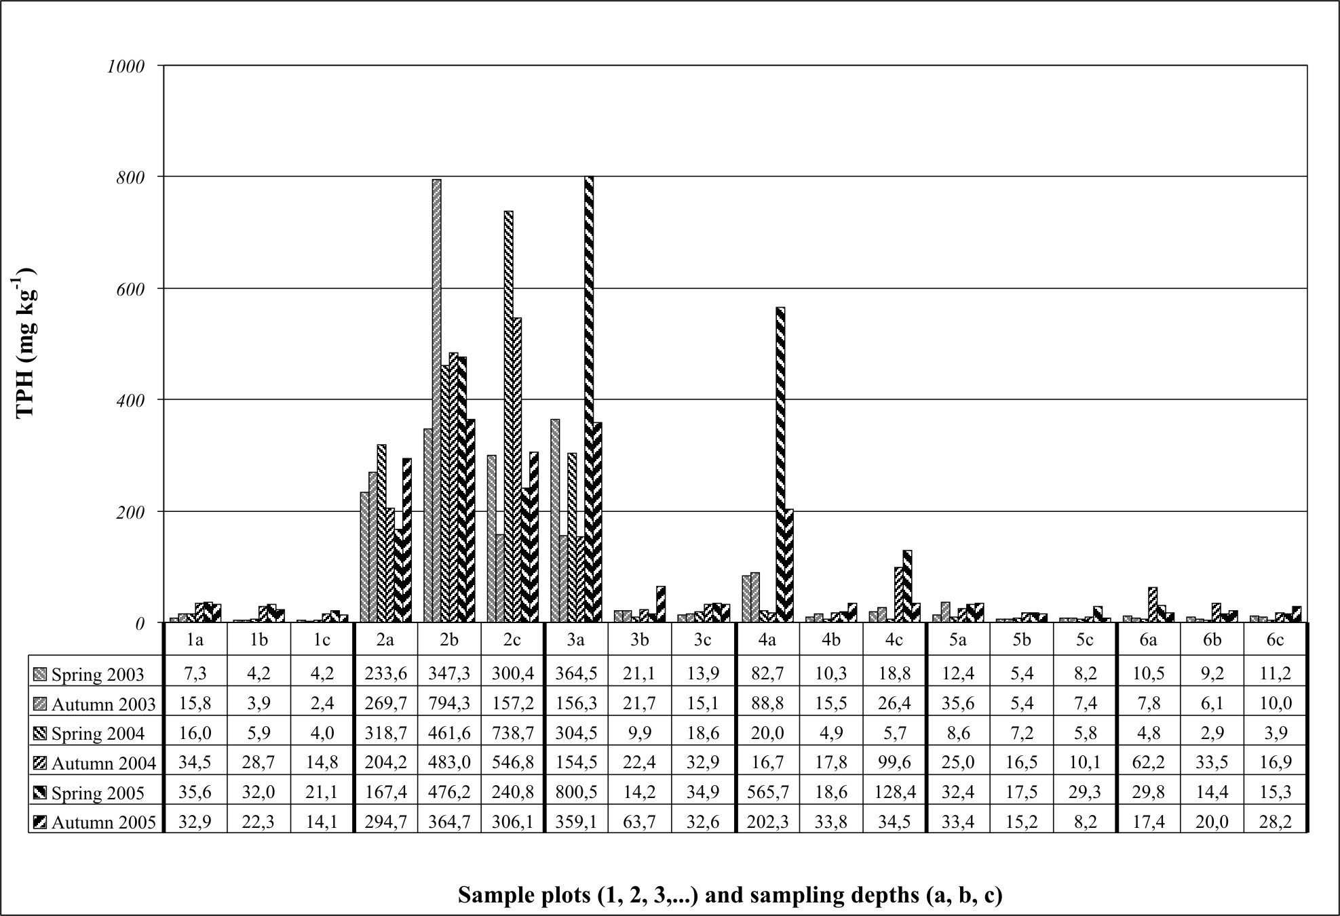
Figure 3. Total petroleum hydrocarbons in the soil.

Relatively high values were obtained for total petroleum hydrocarbons by analysing samples from the surface soil layer in plot 3. They also indicate weak to medium contamination with petroleum hydrocarbons (Toti et al. 1998). TPH concentrations in this layer are significantly higher than in the deeper layers (Table 6). In layers a and c, TPH concentrations are significantly higher in relation to the control plot.
Distinctly high TPH concentrations in plot 4 were recorded in the soil surface part during 2005. In plot 4, two measurements revealed increased values of TPH concentrations in layer c (Figure 3). In relation to the measurement period of 3 years, significantly higher values than those in the control plot were found only in layer c (Table VII). Within the same plot, the values in layer b are at the geogenic level and are significantly lower than those in layers a and c (Table VI).

TABLE VI
Within-plot comparisons of TPH concentrations (different soil depths in the same sample plot). Numbers indicate plots. Characters indicate soil depths (a: 0-10cm, b: 30-50cm, c: 70-100cm). Statistical significance of differences (at probability level of p=0.05) yielded by Wilcoxon test is indicated by x (xx indicates significance yielded by Wilcoxon and Sign test).
 | 1a | 1b | 1c | 2a | 2b | 2c | 3a | 3b | 3c | 4a | 4b | 4c | 5a | 5b | 5c | 6a | 6b | 6c
a |  | xx | xx |  | xx |  |  | xx | xx |  | x |  |  | xx | xx
b | xx |  | x | xx |  |  | xx |  |  | x |  | xx | xx
c | xx | x |  |  |  |  | xx |  |  |  | xx |  | xx

TABLE VII
Between-plot comparisons of TPH concentrations (each soil depth in the polluted plot with the respective depth in the control plot). Numbers indicate plots. Characters indicate soil depths (a: 0-10cm, b: 30-50cm, c: 70-100cm). Statistical significance of differences (at probability level of p=0.05) yielded by Wilcoxon test is indicated by x (xx indicates significance yielded by Wilcoxon and Sign test).
 | 1 | 2 | 3 | 4 | 5
a |  | xx | xx
b |  | xx
c |  | xx | xx | xx

In plots 3 and 4, high TPH concentrations in the surface layer decrease from spring to autumn (Figure 3).
In all other cases (plots 1, 5 and 6, and some layers in plots 3 and 4), the measured values indicate the natural content of chain hydrocarbons in the soil. It should be pointed out, however, that in plots 1 and 5 (and in all other plots except the control plot) there are significant differences in TPH concentrations in individual layers (Table VI). In plot 1 they are manifested as a significant decrease in concentrations per depth, and in plot 5 as a significantly higher concentration in the surface layer. Furthermore, plot 5 has a significantly higher TPH concentration in the surface layer than the control plot (Table VII).

- Discussion

Sites of mineral oil discharge into the soil are frequently characterised by the contaminated environment long after their restoration. This is threatening if contamination affects groundwater or flowing water. If pollution is of larger proportions (larger quantities of spilled oil), vegetation in the forest ecosystem declines. Accidents in an oil field may result in the total decline of ground vegetation, which depends on the extent to which crude oil has affected the roots or the aboveground plant parts. Forest trees and shrubs with deeper roots usually react by individual dieback. In this sense, of particular interest is the impact of pollutants in plots 3 and 4, where increased TPH concentrations in the soil were recorded. Since several years have passed since the accident, there is no acute tree dieback. TPH content indicates successfully reclaimed soil (Toti et al. 1998), as well as a well-regenerated layer of ground vegetation. However, there is sporadic dieback of physiologically weakened trees (black alder), especially in plot 3, although increased pollutant concentrations have only been measured in the surface part of the soil. Such a phenomenon, among other things, raises the issue of the condition of symbiotic micro-organism populations in the soil.
Many organisms require specific ecological niches for population growth and colonisation (Daubaras and Chakrabarty, 1992). Such niches are regulated by factors such as light, temperature (climate, daily and seasonal temperature fluctuations), pH, oxygen and nutrients, organic and inorganic pollutants, etc. (Rieser-Roberts 1998). Research of Margesin and Schinner (1997) shows the importance of microbiological activity in decreasing the hydrocarbon level in oil-contaminated soil.
All biological, chemical and biochemical processes that determine the behaviour of pollutants in natural conditions largely depend on the interaction of compounds with the solid soil phase, or on their sorption in the soil (Picer 2000). Soil has a relatively high adsorption constant for oils (Nash, 1987) and it rises with an increase in the content of humus and clayey particles in the soil. Soil with higher clay content allows for the formation of more stable organomineral forms through bindings of pollutants with clay minerals. This research leaves the possibility of such a conclusion in the case of plot 3. Interestingly, in the deeper soil layers of this plot (layers b and c), the values for TPH concentrations do not differ from those in the control plot despite the fact that relatively large quantities of crude oil were spilled in this plot 20 years ago (the largest spill ever in this oil field). We assume that the reason for this is the clayey texture (Tables 2 and 3 – currently, the texture in the surface part is loamy due to the sand introduced during restoration operations), which prevented fluid penetration deeper in the soil.
Oils and soil particles form hydrophobic organogenic and organomineral compounds. Their mobility and rate of spreading in the soil depends on soil features and pollutant characteristics. These are in the first place water solubility, fluidity and dynamic viscosity (Litz 2004). This research has also encountered a pollutant containing over 50% of water (currently the water in this field participates with over 90% in the majority of the wells), which has high salt concentrations. In spite of this fact, no detrimental effects of salt have been recorded in this forest ecosystem and neither has salinization been identified in the soil. This is attributed to the exposure of this ecosystem to floods, which continuously lower temporarily increased concentrations of easily soluble salts, and even remove them entirely.
Plots 3 and 4 are mild micro-relief depressions. Apparently, this characteristic has a profound influence on the presence of pollutants in the soil. With reference to these plots, we believe that the their relief is the principal factor in the redistribution of petroleum hydrocarbons that are occasionally spilled within the oil field and accumulated in the surface part of the soil in micro-depressions. This conclusion is corroborated by the TPH dynamics in plot 3 in 2005. There is an evident decrease in TPH concentrations from spring to autumn, which is attributed to biodegradation, similarly to plot 4 in 2005.
It should be pointed out that non-parametric statistics used here for comparison of within-plot and between-plot differences of TPH soil concentrations did not recognise the existence of large differences in some cases (e.g. 4a vs. 6a, 4a vs. 4c), due to the counting with ranks instead of measured values.
The unexpected occurrence of increased TPH concentration in layer c in plot 4 may be linked with the lateral arrival of pollutants from the canal (100 cm deep and 200 cm wide) situated 10 m from the plot.
A characteristic feature of soil pollution in the forest ecosystem of the oil field is the spatial and temporal variability of pollutant presence. Spatial pollutant variability in plot 2 is evident despite the relatively large composite sample. Very high values of variability, especially for deeper soil parts, are attributed to the fact that the samples were always taken from a different point within a circle of 50 cm in diameter. During the mud ditch reclamation, the solidified deposited material was mixed with lime and sand and deposited. We believe that the impossibility of such material to homogenise successfully is the principal cause of the manifested variability. The consequences of the restoration operation are also aggregates of solidified mass (mud, lime, sand), which currently occur in skeletal form. Such skeleton inhibits soil sampling from deeper layers (layer c) and undoubtedly affects the composite sample variability. The lowest TPH concentration in the surface part of the soil in the restored mud ditch site is explained with a higher proportion of pure soil used to cover the mud ditch during its reclamation.
Temporal variability may be explained by using the example of plot 4, where the redistributed water-rarefied pollutant occasionally penetrates and pollutes the soil, while in plot 3 it is probably a regular form of pollution. Increased pollutant values in such cases may be observed for some time after the retreat of floodwater. They depend on flood frequency, pollutant concentrations in floodwater, and soil features.
No increased TPH residual concentrations were recorded in plots 1 and 5. Low concentrations in these plots are understandable in view of the small quantities of spilled fluid. Still, it is significant that the TPH concentrations in the surface soil part are significantly higher than in the control plot.
As for vegetation in the studied plots, a significant proportion of dry black alder trees were found in plot 3. Moreover, in plots 2 and 3 the exceptionally rich ground vegetation consists of a smaller number of species than in other plots. Additional research is required to show the extent to which such occurrences may be attributed to crude oil pollution in this oil field.

- Conclusion

Research in the plots situated in the oil field has shown significant differences in petroleum hydrocarbon concentrations. Increased TPH concentrations were identified in several plots, while the values measured in other plots indicate very small quantities of residual petroleum hydrocarbons in the soil.
Of the plots exposed to oil pollution after the pipeline rupture, the constant presence of increased petroleum hydrocarbon concentrations in the surface soil part (on average > 200 mg kg⁻¹) was identified in one plot (plot 3) in the form of weak to medium contamination. This plot is situated in a micro-depression contaminated with a large quantity of oil in an accident 20 years ago. Additionally, it is regularly exposed to seasonal flooding. In one of the plots (plot 4), which is partly situated in a less distinct micro-depression, TPH concentrations are usually at a normal level after it has been successfully restored. The permanently increased TPH concentration in plot 3 and the occasionally increased TPH concentration in plot 4 indicate soil pollution in the micro-depressions with pollutants from floodwater in the winter-spring period.
In the mud ditch site, average values of TPH concentrations vary from 200 to 400 mg kg⁻¹. The highest variability was found in the deeper soil layers due to the skeleton of the fragmented solidified mud.
Only in the control plot were no significant differences in TPH concentrations among different soil layers in the same locality recorded.
This research shows that the soil in the sample plots was not contaminated with easily soluble salts and heavy metals. Based on the low values of TPH concentration in the water eluate of the soil, we may conclude that the soil does not represent a source of hydrospheric pollution.
Based on the obtained results and the observations of vegetation in plots 2 and 3, we believe that this research would benefit from an analysis of ground vegetation and microbiological activity in the soil. It would also be interesting to expand the sample to several more sites where major fluid spills have taken place or which are located in micro-depressions.

References

Adeniyi, A. A. and Afolabi, J. A., 2002: ‘Determination of total petroleum hydrocarbons and heavy metals in soils within the vicinity of facilities handling refined petroleum products in Lagos metropolis’, Environment International, 28(1-2), 79-82

Alexander, M., 1994: Biodegradation and Bioremediation. AP, San Diego, CA 302 pp.

Basic, F., Prpic, B. and Tomic, M., 1993: ‘Impact of exploring, production and transport of oil and gas on the environment – locality of town of Ivanic’, Study, Faculty of Agriculture, University of Zagreb, 80 pp.

Berry, K.A. and Burton, D.L., 1997. ‘Natural attenuation of diesel fuel in heavy clay soil’, Can. J. Soil Sci. 77, 469–477.

Burkhardt, C., Insam, H., Hutchinson, T. C. and Reber, H. H., 1993: ‘Impact of heavy metals on the degradative capabilities of soil bacterial communities’, Biol. Fertil. Soils. 16, 154-156.

Casella, S. and Payne, W. J., 1996: ,Potential of denitrifiers for soil envinonment protection’, FEMS Microbiol. Lett. 140(1), 1-8.

Chaineau, C.H., Yepremian, C., Vidalie, J. F., Ducreaux, J., and Ballerini, D., 2003: ‘Bioremediation of a crude oil-polluted soil: biodegradation, leaching and toxicity assessments’, Water and Air Soil Pollut. 144, 419–440.

Chander, K and Brooks, P. C., 1991: ‘Effects of heavy metals from past application of sewage sludge on microbial biomass and organic matter accumulation in a sandy loam soil and silty loam’, UK Soil Biol Biochem 23, 927–932.

Daubaras, D. and Chakrabarty, A. M., 1992: ‘The environment, microbes and bioremediation: microbial activities modulated by the environment’, Biodegradation 3, 125-135.

Dibble, J. T. and Bartha, R., 1979: ‘Effect of environmental parameters on the biodegradation of oil sludge’, Appl. Environ. Microbiol. 37, 729-739.

Diels, L., Springael, D., Kreps, S., and Mergeay, M., 1991: ‘Construction and characterisation of heavy metal resistant, PCB- degrading Alcaligenes sp. Strains’, in Hinche, R. E. and Olfenbutel, R. F., (eds.), On. Site Bioreclamation: Processes for Xenobiotic and Hydrocarbon Treatment, Butterworth-Heinemann, Stoneham, MA, USA, pp. 483-493.

Hirner, A. V., Grüter, U. M. and Kresimon, J., 2000: ‘Metal(loid) organic compounds in contaminated soil’, Fresenius J. Anal. Chem. 368, 263-267.

Husnjak, S. and Sraka, M., 1994: ‘Pedological investigation after mud ditches reclamation in Zutica oil field in Posavina region. Faculty of Agriculture’, University of Zagreb, HR, 35 pp.

Koomen, I, McGrath, S. P., and Giller, K. E., 1990: ‘Mycorrhizal infection of white clover is delayed in soils contaminated with heavy metals from past sewage sludge applications’, Soil Biol Biochem 22, 871–873

Litz, N., 2004: ‘Organische Verbindungen’, in Blume, H. P., (ed), Handbuch des Bodenschutzes, 3. Auflage, Ecomed, Landsberg am Lech, D, 916 pp.

Margesin, R. and Schinner, F., 1997: ‘Bioremediation of diesel-oil-contaminated alpine soils at low temperatures’, Appl. Microbiol. Biotechnol. 47, 462-468.

McBridge, M. B., 1994: Environmental chemistry of soils, Oxford University Press, Inc, New York, NY, USA, 406 pp.

Nash, J. H., 1987: ‘Field studies of in situ soil washing’. EPA-600/2-87/110. U S EPA Cincinnati, OH, USA, PB 8814608.

Oldeman L. R., Hakkeling, R. T. A. and Sombrock, W. G., 1991: World map of the status of human-induced soil degradation with explanatory note (second revised edition), ISRIC, Wageningen, NL; LTNEP, Nairobi and UNEP.

Ott, R.L., 1993: Introduction to Statistical Methods and Data Analysis, Duxbury Press, Belmont, CA, USA, 1152 pp.

Picer, M. and Picer, N., 2000: ‘Soil pollution by stable organic matters and their reclamation’, Hrvatska vodoprivreda, the journal of Croatian water public enterprise, Zagreb, HR, 9(99), 71-77.

Rieser-Roberts, E., 1998: Remediation of petroleum contaminated soils, CRC Press LLC, Boca Raton, FL, USA, 542 pp.

Rukavina, Z., Juretic, Z., Misevic, V., Tomic M. and Vitezic, M., 1990: Mud ditch reclamation in the INA-naftaplin company, the main standardized mining project, INA – petroleum industry Ltd. Zagreb, HR, 64 pp.

Roane, T M and Kellogg, S. T., 1996: ‘Characterization of bacterial communities in heavy metal contaminated soils’, Can J Microb. 42, 593–603.

Sarkar, D., Ferguson, M., Datta R. and Birnbaum, S., 2005: ,Bioremediation of petroleum hydrocarbons in contaminated soils: comparison of biosolids addition, carbon supplementation, and monitored natural attenuation’, Environmental Pollution, 136(1), 187-195.

Toti, M., Constantin, C., Dracea, M., Capitanu, V. and Damian, M., 1998: ‘Some aspects concerning the oil pollution and brine in Romanian soils’, Stinta sollului, Soil Science Journal of the Romanian National Society of Soil Science, 1-2, 177-187.

Vrbek, B., 1998: ‘Pedological properties of “Zutica” forest managament unit, with map M 1:10.000’, Study, Forest research institute Jastrebarsko, HR, 26 pp + map.

Xiong, Z. T., Hu, H. X., Wang, Y. X., Fu, G. H., Tan, Z. Q. and Yan, G. A., 1997: ‘Comparative Analyses of soil Contaminant Levels and Plant Species Diversity at Developing and Disused Oil Well Sites in Qianjiang Oilfield, China’, Bull. Environ. Contam. Toxicol. 58, 667-672.

Mud ditch restoration involved solidification of mud with lime and bentonite and covering it with a layer of soil (Rukavina et al. 1990). Control pedological research in the restoration site was regularly conducted after the restoration (Husnjak and Sraka 1994). There are almost no new drilling operations at present, so all the waste ensuing from the repairs or restorative activities in the oil field area is disposed in the central disposal site.

