SOME PHYSICAL AND MECHANICAL PROPERTIES OF BEECH WOOD GROWN IN CROATIA
Slavko Govorčin- Tomislav Sinković-Jelena Trajković
Forestry Faculty in Zagreb
ABSTRACT

Beech-wood ( Fagus sylvatica L. ) is a typical European wood species found in the moderate oceanic and tender continental climate. Because of its
utilization in making army wagons and gun-stock it was once a synonym for 'military' wood in the tradition of the European nations, and millions of cubic meters were burnt in army stoves and field kitchens.
Distribution, quantity share and characteristic technological quality categorize beech-wood as one of the main species in industrial processing of wood in Croatia.
The number of previous studies of the technological properties of beech-wood grown in Croatia corresponds to its presence and importance, which is evident from a number of sites within the beech-wood range on which the studies were carried on. ( Fig.3 ).
Examinations of physical and mechanical properties of beech-wood from the site of Bjelolasica ( Gorski kotar ) were made on sampling material at three tree heights, which was different from previous studies. The maximum number of samples, looking from pith to bark i.e. in the radial direction, enabled an insight into distribution of beech-wood properties through characteristic zones of a tree during their life. Considering a great number of up to the present studies of beech-wood properties in Croatia on
different above-sea heights of the sites, a significant dependence of
properties on above-sea heights was observed.
KEY WORDS: Beech-wood ( Fagus sylvatica L. ), physical properties, mechanical properties, Croatia
INTRODUCTION

The area of natural distribution of ordinary beech-wood covers up almost the whole Europe. As mountain species, it reaches the South all the way to Sicily (ϕ=37° ), but it can't be found in Spain nor Greece. In the North, it spreads to the northern part of Scotland, southern part of Sweden ( up to ϕ=59° ), and in the Eastern Prussia up to Kaljingrad. The southern border goes from Kaljingrad towards Kisinjevo in Besarabia in the shape of an arc protruding out into the West. In the Southwest direction it spreads from the slopes of the Transilvanian Alps to the Danube, and then heads towards East through the northern part of Bulgaria to the Black sea. The southern border of its distribution goes to the Strandza mountains in Turkey to the West ,mainly to the Greek state borders and then spreads, beginning from Bitolj, to the South to the Pind mountains in Greece and from there to the Ionic sea. ( Fig. 1 ).
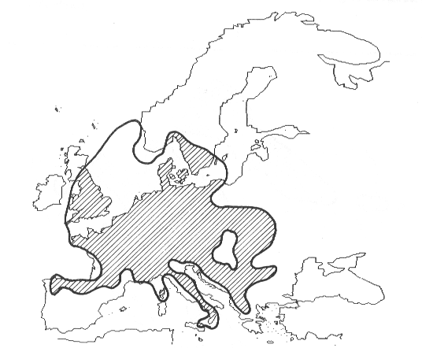
Fig.1: The distribution range of beech wood ( Fagus sylvatica L.) in Europa.

The conclusion is that beech wood represents a species of moderate oceanic and tender continental climate. But the distribution in the above mentioned area is not even. It can't be found in the French province of Provence, Italian Lombardia, the pine-wood area of the central Alps, the middle part of the Czech Republic. It is explained by the fact that beech-wood is a mezofit and it requires abundant rains during summer, which doesn't occur in the mentioned areas.
For the same reason, it can't be found in Croatian areas of the mediterranean and submediterranean climate ( Istria, Hrvatsko primorje, most part of Dalmatia ). From the North of Croatia, beech-wood grows in the direction of the SouthWest ( Hrvatsko Zagorje- Slavonia ) and in the middle part of Croatia ( Gorski kotar, Lika, Kordun and Banija ). In
Hrvatsko primorje it appears above 600 m above-sea, beginning with stunted forms. Its bottom border is distributed and registered on the above-sea height of 112 m near Bjelovar and on the above-sea height of 112 m near Novoselec and at 103 m above-sea near Karlovac. According to L. Abramović, the upper border of high-altitude distribution lies in the mountains of Velebit, at 1500 m above-sea (Fukarek 1965)( Fig. 2).

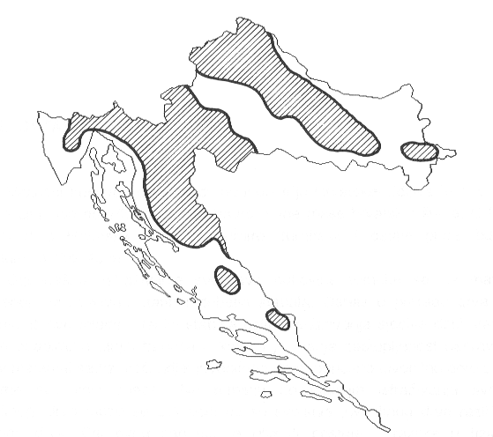

Fig.2: The distribution range of beech wood ( Fagus sylvatica L.) in Croatia.

The beech-wood forests of Croatia belong to the association of Croatian beech-wood forest Fagetum silvaticae croaticum Horv., which is recognized for its great number of distinctive species and thus represents the richest form of beech-wood forests in Europe.
The range of Croatian beech-wood forests can be divided into 3 variations ( subassociations ), according to the above-sea height.The lowest area, i.e. the one up to ca. 700 m ab.s. belongs to the mountain beech forests, Fagetum croaticum montanum Horv. In the area from 700 / 1000 - 1.300/1.400 m. ab.s. grows a forest of beech-wood and fir-wood Fagetum croaticum abietetosum Horv. Above it, there is a mountain beech-wood forest, Fagetum croaticum subalpinum Horv., with pure beech which transforms into a elder bush*. On silicate grounds in the range of ca. 350-550 m. ab. s., there is a acidofilna association of hard fern and beech-wood, Blechno-Fagetum Horv., which transforms into a forest of sessile oak and sweet chestnut, Quercus-Castenum croaticum Horv., and the in the higher parts into a forest of hard fern and fir-wood. On the slopes heading towards the sea there is a coastal forest of beech-wood Fagetum croaticum seslerietosum Horv. which covers an area of ca. 600-1000 m-ab.s. and which, in higher parts, transforms into a forest of beech-wood and fir-wood Fagetum croaticum abietetosum Horv. ( Herman 1986).
The importance of beech wood as wood species in Croatia is evident in the total wood stock of Croatian forests of 39,9%, i.e. 80 million of cubic metres . It grows in the area of around 250 000 ha in pure stand, in mixed stand with sessile oak and hornbeams in the area of ca. 700 000 ha, and with fir-wood and spruces it covers the area of ca. 200 000 ha . The annual felling in Croatia makes 1,7 million m3 of gross mass, i.e. 500 000 m3 or 45% of saw-mill hardwood logs or ca. 32% of total produced mass of saw-mill logs in Croatia. For making sliced and rotary cut veneer , around 115 000 m3 of beech-wood logs were used i.e. 48,5% of the total produced mass of veneer logs ( Klepac 1986).
Mean values of some physical and mechanical properties of beech-wood at breast height determined by previous studies in Croatia are illustrated in Tab.6.
The values of some physical and mechanical properties of beech-wood taken from the previous published references : density ρ₀=0,68 g/cm³ , volumetric shrinkage β_{V max}=17,6%, compression strength parallel to the grain σ_{12%}=62 MPa ( Kollman 1951, Bosshhard 1974 ) are out of date to a certain extent.
Density ρ₀=0,70 g/cm³, volumetric shrinkage β_{V max}=17,6%, compression strength parallel to the grain σ_{12%}=46 MPa , static bending strength σ_{b14%}=104 MPa ( Tsoumis 1991, Wood Handbook, FPL 1999 ) represent more recent data on the values of some physical and mechanical properties of beech-wood.
MATERIAL AND METHODS
From 1956 to the present time, physical and mechanical properties of beech wood have been studied on seven Croatian sites, by means of methods adequate to the period and the then possibilities. Almost the whole area of beech wood distribution in Croatia was covered (see Fig.3). According to the information gotten from the sites of the former studies, an area was chosen in which a study of beech wood properties hadn’t been carried on before. The site of Bjelolasica in Gorski kotar was chosen, with its 1150-1200 m above-sea height.

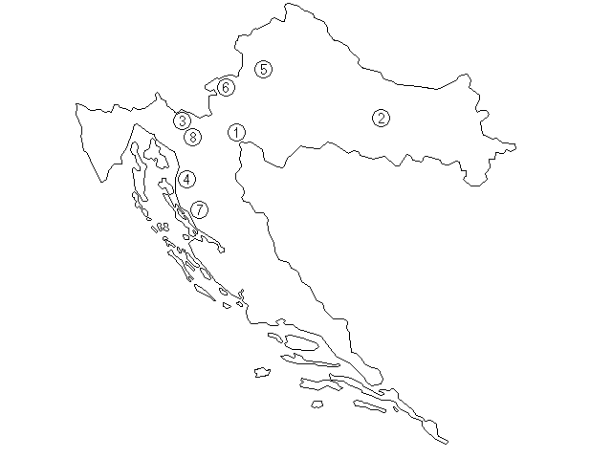
- Petrova gora
- Papuk
- Gorski kotar
- Senjsko bilo
- Zagrebačka gora
- Žumberak
- Velebit
- Bjelolasica

Fig.3: Map of sites for studies of physical and mechanical properties of beech wood in Croatia.

On the site of Bjelolasica ( Gajina lokva – division 47a, area 49,42 ha ) 15 specimens were taken out of 5 diameter classes. After felling, test small logs ( 70 cm of length ) and test wood discs ( 4 cm of thickness ) were removed from each tree at 3 sampling heights ( at 1,3 m – breast height, at ca. 5 m – the center of length between ground and the crown base, and at and at ca. 10 m – before the beginning of crown ). From the test logs two groups of samples were cut following ISO standards, prismatic ( symmetrical ) ones for determining physical properties and others to determine mechanical properties. From the test girdles, samples of unsymmetrical forms were cut in order to determine physical properties. While making samples of symmetrical and unsymmetrical forms, the principle of making the biggest possible number of samples in the radial direction was employed, in all four cardinal points, with material loss occurring only at the points of sawkerf.

RESULTS AND DISCUSSION
The results of physical and mechanical properties’ study are based on the values obtained by a very large number of samples. The values of properties distribution in the radial direction are given, for easier reference, in tables and graphs as mean values of 20 rings intervals. The results shown in this paper are based on the values of all studied samples at breast height ( 1,3 m ) in order to compare them with the so-far studies on other sites, depending on above-sea height of the sites.
The illustrated values of volume shrinkage and density of owen dry wood are founded on the results obtained by studying of symmetrical and unsymmetrical forms, while the values of growth rate, compression strength parallel to the grain and static bending strength are based on the results gotten from the study of symmetrical forms.

Growth rate

Distribution of mean ring width in the radial direction at breast height is given in Tab.1.

RANGE OF RINGS | RING WIDTH (mm)
 | n | MV | SD
1-20 | 1 194 | 0,9 | 0,494
21-40 | 1 200 | 0,85 | 0,529
41-60 | 1 124 | 0,76 | 0,534
61-80 | 1 040 | 0,74 | 0,460
81-100 | 1 040 | 0,75 | 0,520
101-120 | 984 | 0,81 | 0,534
121-140 | 960 | 0,86 | 0,570
141-160 | 960 | 0,97 | 0,647
161-180 | 880 | 1,15 | 0,739
181-200 | 676 | 1,40 | 0,822
201-220 | 320 | 1,61 | 0,818
221-254 | 208 | 1,50 | 0,456
MEAN | 10 586 | 0,93 | 0,63

Tab. 1: Statistical characteristics of ring width for range of rings.
n-number of samples
MV-mean value
SD- standard deviation

It is evident that growth rate decreases in the radial section from the pith to the bark ( 70 years of age ), while the trend of value increase is evident towards the bark ( Fig. 4 ). The maximum mean value of the growth ring interval ( 1,61 mm of width ) is 117% bigger than the minimum mean value of the interval ( 0,74 mm of width ).
Fig. 4: Ring width (mm)

Volumetric shrinkage

The volume shrinkage values are illustrated in Tab. 2, while a graphic illustration given in Fig.5 reveals a general decrease of the volumetric shrinkage values in the radial direction from pith to bark, with a significant decrease of value in the first ca. 80 rings. The maximum mean value of the volumetric shrinkage interval ( 18,3 % ) is 14,4 % bigger than the minimum mean value of the interval ( 16,0 % ).

RANGE OF RINGS |  |  | VOLUMETRIC SHRINKAGE (%)
 | n | MV |  | SD
1-20 | 47 | 18,3 |  | 2,90
21-40 | 91 | 17,4 |  | 2,35
41-60 | 69 | 17,2 |  | 2,34
61-80 | 50 | 17,4 |  | 1,81
81-100 | 61 | 17,3 |  | 1,24
101-120 | 53 | 16,8 |  | 1,30
121-140 | 59 | 16,7 |  | 1,77
141-160 | 65 | 16,5 |  | 1,58
161-180 | 59 | 16,4 |  | 1,67
181-200 | 57 | 16,4 |  | 1,82
201-220 | 33 | 16,0 |  | 1,61
221-254 | 20 | 16,7 |  | 2,06
MEAN | 664 | 17,0 |  | 2,01

Tab.2: Statistical characteristics of volumetric shrinkage for range of rings.
n-number of samples
MV-mean value
SD- standard deviation

Fig. 5: Volumetric shrinkage (%)
Density

Distribution of the density values of owen dry wood in the radial direction is given in Tab. 3. The graphic illustration (see Fig.6) shows a significant decrease of the density values in the first ca. 70 rings from pith to bark, at a somewhat slower rate. The maximum mean value of the density interval in absolute dry conditions ( 0,714 g/cm³ ) is 11,6 % bigger than the minimum mean value of the interval ( 0,640 g/cm³ ).

RANGE OF RINGS | DENSITY OF OWEN DRY WOOD (g/cm³)
 | n | MV | SD
1-20 | 47 | 0,714 | 0,0720
21-40 | 91 | 0,689 | 0,0646
41-60 | 69 | 0,670 | 0,060
61-80 | 50 | 0,674 | 0,0467
81-100 | 61 | 0,664 | 0,0288
101-120 | 54 | 0,651 | 0,0386
121-140 | 59 | 0,651 | 0,0472
141-160 | 66 | 0,662 | 0,0565
161-180 | 59 | 0,665 | 0,050
181-200 | 57 | 0,657 | 0,0529
201-220 | 33 | 0,640 | 0,0454
221-254 | 20 | 0,654 | 0,0407
MEAN | 666 | 0,669 | 0,055

Tab. 3: Statistical characteristics of density of owen dry wood for range of rings.
n-number of samples
MV-mean value
SD- standard deviation

Fig.6: Density of owen dry wood (g/cm³)

Compression strength parallel to the grain

The values of compression strength parallel to the grain are illustrated in Tab. 4, and the graphic illustration in Fig.7 reveals a slight increase of the values in the first 70-80 rings, followed by a more severe decrease of the values, with the minimum value around the bark. The maximum mean value of the compression strength parallel to the grain ( 52,0 MPa ) is 14% bigger than the minimum mean value of the interval ( 45,6 MPa ).

RANGE OF RINGS |  | COMPRESSION STRENGTH PARALLEL TO THE GRAIN (MPa)
 | n |  | MV | SD
1-20 | 25 |  | 46,9 | 4,94
21-40 | 45 |  | 49,4 | 4,54
41-60 | 46 |  | 52,0 | 6,33
61-80 | 66 |  | 50,5 | 4,73
81-100 | 49 |  | 50,7 | 4,21
101-120 | 64 |  | 50,4 | 4,37
121-140 | 61 |  | 49,9 | 4,40
141-160 | 69 |  | 48,8 | 4,64
161-180 | 66 |  | 47,3 | 3,75
181-200 | 52 |  | 45,6 | 3,61
201-220 | 19 |  | 47,2 | 2,25
221-254 | 14 |  | 46,9 | 2,04
MEAN | 576 |  | 49,1 | 4,77

Tab. 4: Statistical characteristics of compression strength parallel to the grain for range of rings.
n-number of samples
MV-mean value
SD- standard deviation

Fig.7: Compression strength parallel to the grain (MPa)

Static bending strength

The values of static bending strength are illustrated in Tab. 5, and the graphic illustration in Fig. 8 reveals a slight increase of the values in the first ca. 70 rings, followed by a more severe decrease of the values, with the minimum value around the bark. The maximum mean value of the static bending strength ( 107,4 Mpa ) is 25,6% bigger than the minimum mean value of the interval ( 85,5 Mpa ).

RANGE OF RINGS |  | STATIC BENDING STRENGTH (MPa)
 | n |  | MV | SD
1-20 | 11 |  | 96,7 | 16,74
21-40 | 19 |  | 105,1 | 13,23
41-60 | 21 |  | 107,4 | 19,24
61-80 | 27 |  | 104,2 | 11,39
81-100 | 22 |  | 100,8 | 10,40
101-120 | 30 |  | 102,2 | 8,34
121-140 | 21 |  | 97,1 | 13,02
141-160 | 31 |  | 96,8 | 10,18
161-180 | 31 |  | 98,0 | 7,95
181-200 | 17 |  | 92,4 | 10,99
201-220 | 10 |  | 95,1 | 14,76
221-254 | 5 |  | 85,5 | 10,62
MEAN | 245 |  | 99,8 | 12,64

Tab. 5: Statistical characteristics of static bending strength for range of rings.
n-number of samples
MV-mean value
SD- standard deviation

Fig. 8: Static bending strength (MPa)

Dependence of some physical and mechanical properties of beech wood grown in Croatia on the height above sea level

The values of some physical and mechanical properties obtained in this study, together with the identical properties gotten from the so-far studies on other Croatian sites, are illustrated in Tab. 6.(Horvat 1959,1965,1969, Štajduhar 1973). The presence of different above-sea heights of the sites on which the studies were done offers an insight into a characteristic dependence of some properties on the above-sea height of the site in question ( Fig..9 – 13 ).

LOCATION | HIGHT ABOVE SEA [m] | n | ring width (mm) | n | volumetric shrinkage (%) | n | density (g/cm³) | N | compression strength parallel to the grain (MPa) | N | static bending strength (MPa)
PETROVA GORA | 390 | 165 | 2,29 | 169 | 17,45 | 165 | 0,703 | 111 | 65,6 | 82 | 132,4
PAPUK | 560 | 224 | 1,60 | 100 | 22,12 | 224 | 0,702 | 225 | 72,3 | 115 | 139,3
GORSKI KOTAR | 620 | 231 | 2,00 | 91 | 22,00 | 231 | 0,698 | 231 | 57,5 | 116 | 130,5
SENJSKO BILO | 780 | 63 | 1,77 | 63 | 16,91 | 63 | 0,674 | 33 | 68,7 | 33 | 132,4
ZAGREBAČAKA GORA | 830 | 242 | 2,70 | 211 | 22,09 | 238 | 0,706 | 237 | 80,2 | 113 | 145,1
ŽUMBERAK | 918 | 107 | 1,51 | 108 | 17,27 | 108 | 0,672 | 95 | 66,9 | 55 | 130,4
VELEBIT | 1055 | 291 | 1,29 | 289 | 16,88 | 289 | 0,651 | 200 | 62,7 | 204 | 119,8
BJELOLASICA | 1157 | 10 586 | 0,93 | 664 | 16,97 | 666 | 0,669 | 576 | 49,1 | 245 | 99,76

Tab. 6: Statistical characteristics of some physical and mechanical properties of beech on eight locations.

Fig. 9: Dependability of average rings width and height above sea level.

Fig.10: Dependability of average volumetric shrinkage and height above sea.

Fig.11: Dependability of density of owen dry wood and height above sea level.

Fig.12: Dependability of average compression strength parallel to the grain and height above sea.

Fig.13: Dependability of average static bending strength and height above
sea.
CONCLUSIONS

The evident trends of some functions of the illustrated physical and mechanical properties of beech wood in the radial direction reveal a characteristic and typical distribution ( A.J. Panshin and C. de Zeeuw 1970 ) as well as a strong mutual connection between properties. Trends are different from the density function trend at equal functions of the outlined mechanical properties in the first ca. 70 rings. The reasons are to be found in dimension changes of the elements of wood material in that part of a tree ( B. Petrić and V. Šćukanec 1980 ), as well as in the influence of range of rings in the radial direction ( Tab. 1, Fig. 4 ).
A distinct variability of the given properties observed in the radial direction from pith to bark were significant, and they were particularly evident at static bending strength.
A comparison of the data was made possible owing to the accessibility of the values of some up to the present studied physical and mechanical properties obtained from other sites of beech wood in Croatia. A strong dependence of some physical and mechanical properties of beech wood on the above-sea height of the site was reported. A general conclusion is that the values of the studied physical and mechanical properties get reduced with the increase of the above-sea height of the site.

REFERENCES

- Bosshard,H.H., 1974.: Holzkunde 1.Birkhauser Verlag.Basel und Stuttgart, 94 pp.
- Forest Products Laboratory, 1999: Wood handbook-Wood as an
engineering material. Gen. Tech.Rep. FPL-GTR-113. Madison, Wl:U.S.
Department of Agriculture, Forest Service, Forest Products Laboratory.
463 pp.
- 3. Fukarek,P.,1965.:Biološke i ekološke karakteristike bukve i bukovih šuma
u Jugoslaviji.Savjetovanje o proizvodnji,preradi i trgovini bukovim
drvom.Beograd, 1-18 pp.
4. Herman,J.,1971.:Šumarska dendrologija.Stanbiro. Zagreb,230-237 pp.
5. Horvat,I.,1959.:Osnovne fizičke i mehaničke karakteristike bukovine s
područja Žumberka,Petrove Gore,Senjskog bila i Velebita. Zagreb, 1-
94 pp.
6. Horvat,I.,1966.:Izvještaj o ispitivanju nekih fizičko-mehaničkih svojstava
bukovine s područja šumarija Virovitica,Nebljusi i Perušić, manuskripts,
Zagreb.
7. Horvat, I., 1969: Osnovne fizičke i mehaničke karakteristike
bukovine.Drvna industrija, 20 (11-12):183-194.
8. Klepac,D.,1986.:Uvodni referat na simpoziju o bukvi.Kolokvij o
bukvi.Velika- Zagreb. Sveučilište u Zagrebu, Šumarski fakultet. Zagreb
11-15 pp.
9. Kollmann,F.,1951.: Technologi des Holzes und Holzwerkstoffe Erste
band. Springer-Verlag. Berlin und Munchen.
10. Panshin,A.J.and De Zeeuw,K.,1970.: Texbook of Wood
Technology.Vol.1.Mcgraw-Hill book Company.New York, 251-255 pp.
11. Petrić, B., V. Šćukanec, 1980: Neke strukturne karakteristike domaće
bukovine (Fagus sylvatica L). Drvna industrija 31(9-10): 245-246.
12. Štajduhar,F.,1973.:Prilog istraživanja fizičko-mehaničkih svojstava
bukovine u Hrvatskoj.Drvna industrija 24(3-4):43-59.
13. Tsoumis, G., 1991.: Science and technology of wood: structure,
properties, utilization.Chapman&Hall. New York, 111-115 pp.

