Electronic Journal of Polish Agricultural Universities is the very first Polish scientific journal published exclusively on the Internet, founded on January 1, 1998 by the following agricultural universities and higher schools of agriculture: University of Technology and Agriculture of Bydgoszcz, Agricultural University of Cracow, Agricultural University of Lublin, Agricultural University of Poznan, Higher School of Agriculture and Teacher Training Siedlce, Agricultural University of Szczecin, and Agricultural University of Wroclaw.

 | ELECTRONIC  JOURNAL  OF POLISH  AGRICULTURAL  UNIVERSITIES | 2002  Volume 5  Issue 2  Series  WOOD TECHNOLOGY

Copyright © Wydawnictwo Akademii Rolniczej we Wroclawiu, ISSN 1505-0297
SMARDZEWSKI J., PREKRAD S. 2002. STRESS DISTRIBUTION IN DISCONNECTED FURNITURE JOINTS Electronic Journal of Polish Agricultural Universities, Wood Technology, Volume 5, Issue 2.
Available Online http://www.ejpau.media.pl/series/volume5/issue2/wood/art-04.html

STRESS DISTRIBUTION IN DISCONNECTED FURNITURE JOINTS
Jerzy Smardzewski¹, Silvana Prekrad²
¹Department of Furniture Design, August Cieszkowski University, Poznań, Poland
²Department of Wood Construction and Technology, Technical University of Zagreb, Croatia

ABSTRACT
INTRODUCTION
OBJECTIVE OF RESEARCH PROJECT
RESEARCH METHODOLOGY
ANALYSIS OF RESULTS
CONCLUSIONS
REFERENCES

ABSTRACT
The objective of investigations was to determine rigidity and strength of temporary joints applied in cabinet furniture. In particular, the authors intended to determine the distribution of ordinary stresses in wood, metal and plastic connections of temporary joints and in parts of boards in direct contact with these fastenings. The performed laboratory investigations and numerical calculations showed that trapezoid temporary joints with metal construction were characterised by the most advantageous rigidity-strength properties, while wood dowels in these joints were found to play a significant role supporting their strength.
Key words: cabinet furniture, disconnected joints, stress distribution
INTRODUCTION
Attempts to arrive at a product, which is not only aesthetic and functional but also sturdy and not over-invested materially, draw the attention of designers to rigidity-strength problems of designed furniture. On the basis of literature data [1,2,3] it can be stated that durability of furniture depends primarily on the quality of joints. Therefore, they should be characterised by strength and rigidity similar to the strength of individual component elements. One of the more important stages of construction design is to carry out the analysis of mechanical work of the entire system. The objective of such an analysis is to identify displacements and to determine the state of stresses in individual elements. This, in turn, allows the selection of optimal dimensions of component elements of the construction in such a way so as to meet, on the one hand, the requirements of their high strength and, on the other, to reduce expenditure of the adopted solution.
In practice, we use numerical calculations, which employ the method of finite elements (FEM) and they provide a useful tool during the initial stage of engineering design of the product and assist CAD/CAM/CIM systems.
In recent years, following a rapid development of computer techniques and their utilisation in the designing process, increasing attention has been paid to cost and functional aspects of the manufacture of furniture products. There are, however, no papers dealing with the analysis of the state of stresses and deformations in temporary joints of cabinet furniture.
OBJECTIVE OF RESEARCH PROJECT
The undertaken investigations aim at determining rigidity and strength of temporary joints from the group of eccentric and trapezoid joints found in constructions of cabinet furniture. In particular, the authors intended to determine the distribution of ordinary stresses in wood, metal and plastic connections of temporary joints and in parts of boards in direct contact with these fastenings.
RESEARCH METHODOLOGY
Laboratory and analytical investigations were conducted on the following three groups of temporary joints: eccentric fastenings with the symbol VB 36M/19 (Fig. 1a), plastic TZ 28 trapezoid fastenings (Fig.1b) and metal TZ 32 S trapezoid fastenings (Fig. 1c). The objective of laboratory investigations was to determine rigidity and strength of the examined construction nodes and to select values of mean loads necessary to carry out strength calculations.
Fig. 1. Temporary fastenings selected for investigations: a/ VB 36M/19, b/ TZ 28, c/ TZ 32 S

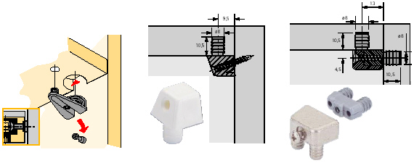

Fig. 2. State of loads turning the furniture body

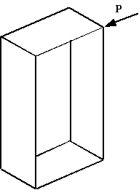
Initial numerical simulations of furniture bodies loaded with operational forces [1,2,3] allowed arriving at the conclusion that joints of adjacent elements of boards are exposed primarily to bending. This was used as the basis for the selection of the most appropriate procedure of loading of angle joints with concentrated forces as shown in figure 3, whereas the obtained maximum values of breaking forces were averaged and introduced into numerical calculations.
Fig. 3. Scheme of sample loading

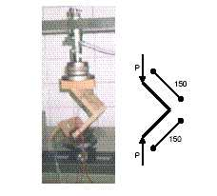
When preparing numerical models of the examined joints, networks consisting of six- and eight node solid finite elements were constructed. Assuming geometry of connected elements as well as fastenings alone, their total consistency with dimensions and shapes of real objects was assured. In addition, it was assumed in numerical models that board elements were not in direct contact with one another but only through selected temporary joints. That is why a small distance of 0.1 mm was applied between board edges (Fig. 4).
Fig. 4. Numerical models of joints: a/ VB 36M/19, b/ TZ 28, c/ TZ 32 S

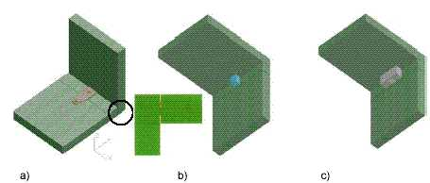
Elastic properties of chipboards necessary for rigidity and strength calculations were determined experimentally, whereas appropriate metal and plastic properties were assumed on the basis of data given by the manufacturer of fastenings. The obtained numerical values are shown in Table 1.
Table 1. Elastic properties of materials used to make joints

Type of material | Young’s modulus [MPa] | Kirhchoff’s modulus [MPa] | Poisson coefficient
Chipboard | 2.948,46 | 1.147,70 | 0,3
Beech wood | 12.000,00 | 4.615,38 | 0,3
Metal | 202.000,00 | 77.692,31 | 0,3
Plastic | 3.500,00 | 1.346,15 | 0,3
ANALYSIS OF RESULTS
Courses of deformations of angle joints presented in Figure 6 allow concluding that the trapezoid TZ 28S joint turned out to be characterised by the highest strength and rigidity. It was found to carry the highest loads but, at the same time, suffered the smallest linear deformations. Therefore, beginning with Young’s equation and Maxwell-Mohr’s force method, it is possible to compare analytically the obtained characteristics and calculate substitute rigidity moduli for angle joints, Therefore, assuming that:
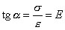 | and that | 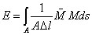
for the scheme of loads from figure 3, we obtain the following equation:
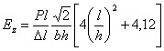
and hence, numerical values of substitute rigidity moduli for:
• eccentric fastening VB 36M/19 E_{z}= 245,22 MPa
• trapezoid fastening TZ 28 E_{z}=320,6 MPa
• trapezoid fastening TZ 32 S E_{z}=801,6 MPa
Hence, it is evident that the trapezoid fastening TZ 32 S is characterised by a 2.5 times higher rigidity in comparison with other trapezoid fastening TZ 28 and by 3.3 times higher rigidity, in relation to the eccentric fastening VB 36M/19. Apparently, this regularity depended on elastic properties of materials making up the examined joints, since the TZ 32 S fastening was made completely from metal, hence its deformations did not affect the deformation of the entire constructional node. The remaining joints, because of converging characteristics of Young’s moduli with the chipboard modulus, contributed to the increase of linear deformations and poorer rigidity of the joint. In this situation, it was interesting to determine the distribution of stresses in joint elements and their neighbourhood.
Fig. 5. Rigidity characteristics of temporary joints

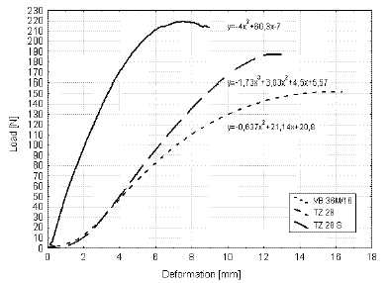

Fig. 6. Stress distribution in elements of angle joints: a) VB 36M/19 b) TZ 28,
c) TZ 32 S

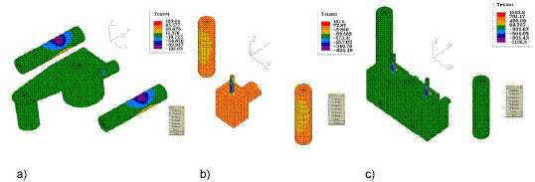
The distribution of ordinary stresses S_{w} presented in Fig. 6 clearly indicate that, in the case of the eccentric fastening VB 36M/19 (Fig. 6a), loads are transferred primarily by wooden dowel pins. Stresses in these elements reached limiting values for beech wood for bending and amounted to approximately 135 MPa. It can, therefore, be assumed that the function of this joint was, mainly, to connect board elements and to transfer small bending moments. In the case of trapezoid fastenings, the most important constructional elements were metal elements screwed into the board. It was these elements that helped nodes achieve rigidity exceeding the rigidity of eccentric fastenings. It is quite evident from Fig. 6b that the metal screw fastened through a trapezoid cube to the chipboard transfers the main operational load in the trapezoid joint. Stresses found in this connection amounted to about 460 MPa, while those in dowels did not reach 90 MPa. This regularity is visible even better in the case of the metal fastening TZ 32 S (Fig. 6c). Here, maximum stresses in metal parts reach the value of 1 000 MPa, and thanks to the symmetrical allocation of screws, the node is characterised by the highest rigidity of all the examined joints. A precise distribution of bending stresses in wooden dowels occurring symmetrically on both sides of the temporary joint is shown in Figure 7.
Fig. 7. Distribution of ordinary stresses S_{w} along the length of dowel

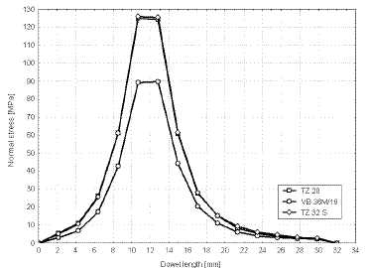
A high concentration of stresses along the length of 12 mm proves that where the two board elements come into contact, we observe bending of beech wood dowels in which efforts reach the limit of wood bending strength. In this case, only firm, metal elements of trapezoid fastenings can guarantee sufficient rigidity of nodes.
Rigidity of metal connectors is particularly important, since it should counterbalance poor bending and compression strength of boards. Especially, the latter parameter contributes to the weakening of constructional nodes. Distributions of stresses in the neighbourhood of the wooden dowel hole indicate that compression stresses in the board exceed considerably acceptable values. In the case of the eccentric fastening VB 36M/19 (Fig. 8a), these stresses reach the value of 39 MPa, in TZ 28 trapezoid joints (Fig. 8b) – about 18 MPa, while in TZ 28 S trapezoid joints (Fig. 8c) – up to 57 MPa. Significant differences in levels of these stresses are, undoubtedly, associated with differences in breaking loads; nevertheless, proportionally to their value, it is joint TZ 32 S that is most advantageous. In the case of this joint, each 1 Newton of breaking load corresponds to 0.20 MPa of effort, as compared to 0.26 MPa - in the case of the eccentric joint and up to 0.32 MPa - in the case of the TZ 28 joint.
Fig. 8. Distribution of ordinary stresses S_{w} in the neighbourhood of dowel hole:a) VB 36M/19, b)TZ 28, c) TZ 32 S

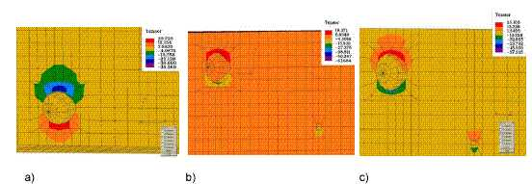
The above-presented results of investigations allowed the authors to draw a conclusion that the nodal rigidity in cabinet furniture with temporary joints depends on joint construction and kind of materials applied to make it.
CONCLUSIONS
The performed investigations as well as the analysis of research results allow drawing the following conclusions:
- Temporary joints from the group of trapezoid fastenings with a metal construction are characterised by the most advantageous rigidity-strength properties.
- The applied numerical model of temporary joints reveals well the character of their work and way of stress distribution.
- Wood dowels used in temporary joints play an important function supplementing the strength of constructional nodes.
When drying green timber of fast growing species, the low temperature schedules should not be applied, especially in summer, when temperature and relative humidity of ambient air are high.
REFERENCES
- Dzięgielewski S.; Leśniewska E.,1983. Właściwości mechaniczne nirozłącznych połączeń o wybranych złączach [Mechanical properties nondisconnected furniture joints]. Pr. ITD Pozn., z.1/2, 12-19 [in Polish].
- Dzięgielewski S.; Smardzewski J.,1989. Jakość połączeń a sztywność mebli skrzyniowych [Joints quality and stiffnes of cabinet furniture]. Przem. Drzew., 11/12, 4-8 [in Polish].
- Smardzewski J.; Dzięgielewski S.,1989. Metody analityczne oceny sztywności korpusów mebli skrzyniowych [Numerical methods of cabinet furniture stiffnes analaisys]. Pr. ITD R. 36, 53-73 [in Polish].

Jerzy Smardzewski
Department of Furniture Design
August Cieszkowski Agriculture University of Poznań
Wojska Polskiego 38/42, 60-627 Poznań, Poland
jsmardzewski@woodcock.au.poznan.pl
Silvana Prekrad
Department of Wood Construction and Technology
Technical University of Zagreb, Croatia
Svetosimunska cesta 25, 10000 Zagreb, Croatia
silvana.prekrad@zg.tel.hr

Responses to this article, comments are invited and should be submitted within three months of the publication of the article. If accepted for publication, they will be published in the chapter headed ‘Discussions’ in each series and hyperlinked to the article.

[BACK] [MAIN] [HOW TO SUBMIT] [SUBSCRIPTION] [ISSUES] [SEARCH]

 | Integrated Design Studies: Furniture
The development of design methods in which experts in design, engineering and manufacturing co-operate.
In a project at Chalmers University of Technology in Göteborg, Sweden, Chalmers is collaborating with the Swedish Testing and Research Institute, SP, and the furniture branch to develop methods for designing furniture. The project is based on integrating experts in design, structural mechanics, materials, testing and manufacturing. The purpose of the project is to develop the design process and to exchange knowledge between different professions with the aid of new computer-based tools and advanced testing methods.
Pilot project "Twice the Strength, Half the Weight"
To give the project a quick start, an in-depth analysis of an existing armchair was made. The chair, which had been designed in the 80s, is a utility product with properties that are so universal that it is a representative object for study.The questions we can ask about the chair's design are more or less general:
Can the armchair be made lighter and stronger? How much lighter? How much stronger?
Is the chair stable? How can the combination of components and joints create stability?
How is the chair loaded? Under which loads is the chair the weakest? How can the chair's components be modified to make the chair stiffer? How much does stiffness increase?
What loads are realistic? Which are the load paths under different loads?
Should the internal loads be steered in a main load path or should two or more load paths be used?
Which joints should be rigid? Which can be elastic? How elastic?
What type of joint is stiffest? Strongest? Plugs, finger joints, straps: Which is best? How much better? How can they be improved? What is the effect of the type of glue?
How can the stiffness of joints be combined to improve the strength and stiffness of the chair? Which joints have the most effect? How great is the effect?
These are topical questions when designing a chair. These questions are, however, difficult to answer with good precision. A furniture designer and a furniture manufacturer usually base their decisions on previous experience and similar products when they design new furniture. Stability and strength are tested on finished prototypes. To the extent that strength calculations are used in designing furniture, they are used as control calculations of designed furniture parts and structures.
A chair is a structural mechanic complex and is difficult to describe in a calculation. Modern computer programmes for advanced structural mechanic analyses of complex structures offer new potential. To obtain results with good precision, however, the structural mechanic performance of the furniture's joints must be modelled; a hitherto rather undeveloped field. Calculations of furniture made of wood additionally presume that stiffness properties in different directions of the material are taken into consideration.
The results of these analyses can be visualised in virtual 3D models. This makes the calculated internal forces and deformations directly accessible for the designer and manufacturer. Visualisation can be the tool with which designers with knowledge of structural mechanics and production experts design new furniture together. This collaboration can then be done interactively with immediate analyses of different variations. Collaboration will no longer be a relay race in which information is sent from specialist to specialist - the process becomes integrated.
At Chalmers University of Technology, major development is underway in fields which integrate design and engineering. As part of the Chalmers programme, Innovative Design, a development studio "Materials and Products" has been formed.
The objectives of the development studio are to:
• Develop design methods in which specialists in design, structural mechanics, material, construction, testing and manufacturing collaborate in new, integrated forms.
• Further develop computer programmes, partly for 3D visualisation of stress fields and deformations in loaded virtual models, partly to simulate the furniture's properties in different respects.
By beginning the studio's work with a pilot project for developing an existing chair, the studio got a quick and tangible start. An existing chair was analysed and developed in a process in which new methods for designing furniture were practised. At the same time, new tools and methods which could support the design process were tested and developed.
Our choice was a stacking armchair which had been designed in the 80s by one of the participants in the Design Studio, designer Olle Anderson. The armchair was intended for public environments and was primarily intended to be a stacking chair for conference rooms and similar places. The design was typical of trends of the time, the measurements were based on knowledge of good sitting ergonomics and, despite being of wood, the chair had great stacking efficiency.
Some of the elements of the design were, however, unconventional and, thus, full of risks from the point of view of construction. The error margins were narrow in the joints and after a long period of use, some of the chairs showed faulty stability. The chair was also felt to be heavy when it was stacked. Considering how often a chair is lifted in a conference room, light weight is a significant detail. The chair is no longer in production.
The task for the pilot project was to develop a chair with the original's function but stronger and lighter by working in co-operation and with the support of new digital tools for simulation and visualisation. The pilot project was spurred on with the name"Twice the Strength, Half the Weight!"
Exhibit
The work in the development studio is presented in images generated during the process of the project.
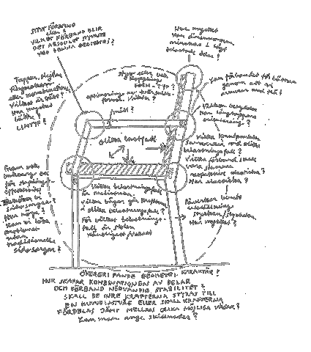
The design process
The sooner you get the answers,
the better the function
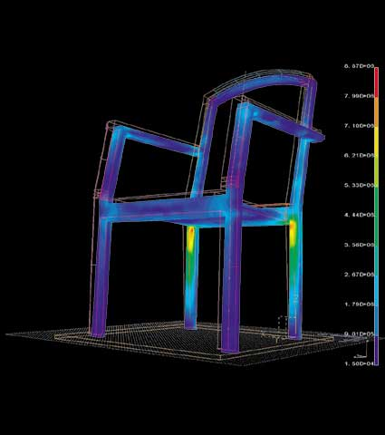
Strength analysis - visualisation of stress concentrations
Is reinforcement needed? Can we redistribute stresses?
Redistribute by adding or taking away material?
Locally or globally?
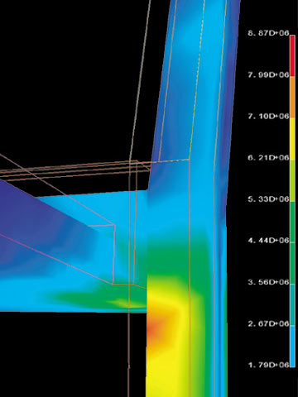
 | Stress concentrations at joints
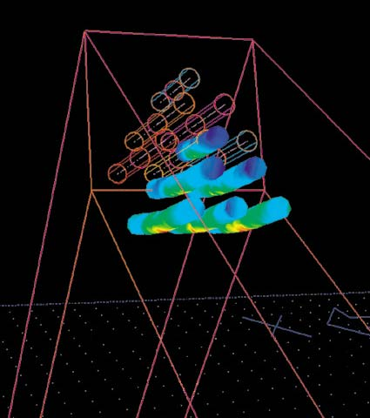
 | Stress concentrations in joints
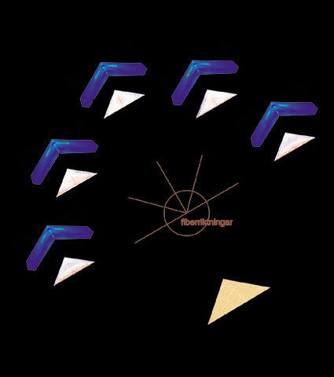
Stress fields in a joint
Steered by material structure - stiffness transmits force
Optimum direction? Reinforce wood with wood?
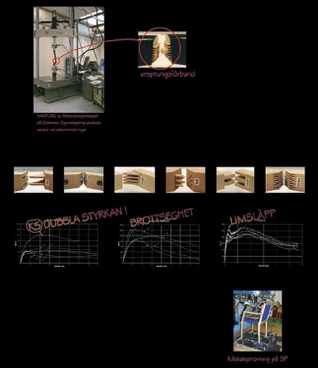
Knowledge of material properties - basis for calculations
Testing joints
Full-scale test
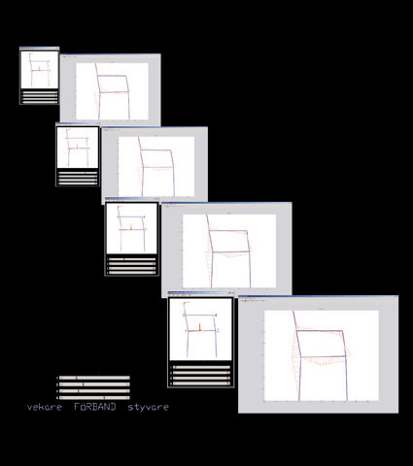
 | Strength analysis
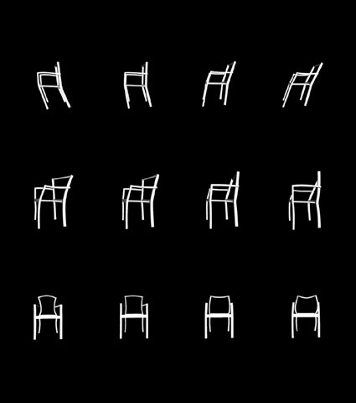
Visualisation of deformation patterns
Under which load is the chair deformed easiest?
How is the pattern affected by a modification of material properties? Of shape?
A few aspects of furniture design from the perspective of structural mechanics:
What is knowledge of structural mechanics?
Knowledge of structural mechanics provides the "rules" that apply on the "playing field" where a substantial part of the design process is played. The rules are valid regardless if the design is intuitive or is anchored in the rules.
The rules are formulated in abstract terms, such as: possible direction of motion, deformation patterns, load paths: and are broken down into the smallest elements, such as: material stiffness, shape, tension that stabilises, compression that destabilises, pre-stress which can change the tension/compression pattern.
The advantage of the structural mechanics' playing field is its formal structure which has distinct limits, but which can also point out possible alternatives: potential for developing the design process.
The advantage of the rules of the game is to provide the language and arguments which explain why impossible solutions are impossible; which with minor modifications make interesting but impossible ideas possible; and which break traditional design habits: joining is not putting in a flat dowel, but preventing two rotations.
What can knowledge of structural mechanics bring to the furniture design process?
Knowledge of structural mechanics deals with three phenomena in particular: stability (possible external and internal shape), stiffness (firmness) and strength (safety). Additionally, fracture behaviour and time dependent (ageing) behaviour are also dealt with.
Global stability describes how furniture and human, as a system, meet the floor/ground. Some central concepts are centre of gravity, balance and rest surface. How do the centre of gravity and the rest surface relate to each other so that a person can safely rest on/in a piece of furniture? How can a global "stationary motion"- a rocking chair - be made to co-operate with our body's sense of balance and at the same time have a positive effect on the shape of our body's own internal structure?
Local stability deals with how a piece of furniture's parts can be joined to co-operate as an internal stable whole. This can be compared with the human being whose internal structure with bones, ligaments and muscles can be shaped for motion (the 100 meter runner) or locked for rest (weightlifter). Which lines, surfaces, volumes and joints give the structure/furniture its intended function? Along with the knowledge of how internal stability is obtained, we also gain clues to how design and details can affect the distribution of forces within the structure and, thereby, influence the structure's deformation properties and capacity for supporting loads.
Stiffness/weakness or firmness is a description of how a piece of furniture receives a human being. Local weakness - for example in the seat-cushion and back - combined with global stiffness -the chair feels safe and stable - is often a comfortable combination. A piece of
furniture that becomes globally weak or "rickety" may have a single weak detail or an interplay between several semi-weak parts. Where in the structure would reinforced stiffness have the best effect? And, how can we bring about this reinforcement on the detail or element level? Material, shape, pre-stress?
When analysing strength or safety, an internal distribution of forces is sought in the structure. This is compared with the local strength, or resistance, of the structure's material. A design that avoids stress concentrations generally means that the piece of furniture can support more load with less material. Often, the measures which lead to an increase in stiffness also increase strength. Sometimes, the opposite is true, through a weaker detail an increase in global strength can be obtained.
How can knowledge of structural mechanics be made available and put to practical use?
The behaviour and properties of structural mechanics can be illustrated by three types of images: images of force (stresses), images of deformation (strains) and images related to material and shape (stiffness, strength and deformation ability). These types of images are available today through commercial software, but are infrequently used in the furniture industry:
• Effective stresses in and deformation of massive bodies, even with complicated geometries.
• Cross-section forces and deformation of structures consisting of elements/frame lines and joints with different characteristics.
• Nuanced description of how the material in a body meets a load (principle stresses: compression, tension, size, directions).
• Images which show how given geometries can be optimised in relation to selected loads.
The reason that these images are commercially available is because they are related to traditional structural mechanic dimensioning methods: a given structure is tested for a number of loads and the results are compared with primarily two criteria: material strength and deformation. This method can be used for many things, but is not always the best way to utilise the rules of structural mechanics in a creative design process.
By beginning with the design process and its need for visual support, new types of images are sought to illustrate the effects and properties of structural mechanics. These images require that existing commercial tools be improved or that entirely new programmes be created. One important criterion is that these images indicate the directions in which the designer can go further in the design process.
Projectgroup Furniture IDS
Kinnarps  Offecct  Swedese  SMI  SP  Chalmers | Urban Wecke  Bo Wremp  Anders Englund  Jan Berger  Bo Wadling  Mikael Calestam  Carl-Johan Johansson  Olle Andersson  Bertil Enquist  Per Eriksson  Ulf Jansson  Karl-Gunnar Olsson  Pierre Olsson  Hans Petersson  Carl Thelin

