Mladen Brezović, PhD
Senior Assistant
Phone: ++385 1 235-2480, e-mail: mladen.brezovic@zg.hinet.hr

Vladimir Jambreković, PhD
Senior Assistant
Phone: ++385 1 235-2478, e-mail: vladimir.jambrekovic@zg.hinet.hr

Stjepan Pervan, PhD
Senior Assistant
Phone: ++385 1 235-2509, e-mail: stjepan.pervan@zg.hinet.hr

Wood Technology Department
Faculty of Forestry
Svetošimunska 25
Zagreb University

10000 Zagreb

Croatia

BENDING PROPERTIES OF CARBON FIBER REINFORCED PLYWOOD
Summary

In previous researches, during bending strength determination of plywood reinforced with bi-directional carbon fibres (fibre quantity was 12 K, meaning 12000 filaments per tow), delamination was noticed in zone of force action, the phenomenon which is not present in ordinary plywood. It was assumed that it was probably caused by great difference between properties of the used materials.
Hence it was presumed that the use of reinforcer with lower quantity of carbon fibres in tow would not decrease bending properties of reinforced plywood.
Five layer plywood reinforced with impregnated carbon fibre cloth was produced to research whether a significant reduction of quantity of carbon fibres had influence on bending properties of reinforced plywood. The carbon fibres used in the experiment had 3000 filaments per tow (3K).
In order to provide better understanding of the problem, models were developed and analysed by use of the Finite Element Method. The achieved results of research were compared to the results of testing non-reinforced plywood and plywood reinforced with 12 K quantity of carbon fibres used in previous researches.

Key words: carbon fibres, reinforced plywood, bending properties, finite element analysis

1. INTRODUCTION

Reinforcers are an important factor in reinforced systems and they have a considerable influence on mechanical properties. This can be clearly seen when reinforcers are used in conjunction with materials of lower mechanical properties where a significant part of their mechanical properties is transferred to the reinforced product (Xu and al. 1998.).
The use of bi-directional carbon fibres as a reinforcer in the construction of plywood has a beneficial influence on their mechanical properties and provides better uniformity of bending properties along the length and width of plywood (Brezović and al. 2002).
During the bending strength tests of plywood reinforced with bi-directional carbon fibres (fibre quantity marked as 12 K, meaning 12000 filaments per tow) the delamination occurs in zone “A” (Fig. 2), which is not common with ordinary plywood. At that point (zone “A”) the tearing of wood fibres occurs and they stay sticked to the adjoining layer (Fig. 2).
After that, plywood suffers an abrupt decrease of compactness and finally fracture occurs caused by bending. In previous researches it was noticed that the main cause of that phenomenon was great difference between carbon fibre properties and properties of used wood species.
The question is how much the quantity of carbon fibres can affect the increase of bending properties of reinforced plywood and whether significantly smaller quantity of carbon fibres would result in significant decrease of those properties.
Considering the fact that the reinforced plywood is made of several materials of different origin and the fact that together with the properties of used materials the interaction between these materials is also important for their bending properties, based on previous researches it can be presumed that the use of reinforcers with significantly smaller share of carbon fibres per tow will have a beneficial influence on bending properties and that they will not be significantly decreased (Brezović and al. 2002).

2. MATERIALS AND METHODS

Five layer plywood reinforced with impregnated carbon fibre cloth was produced to determine whether considerable reduction of carbon fibre quantity had influence on bending properties of reinforced plywood. The carbon fibres used in the experiment had 3000 filaments per tow (3K). General characteristics of carbon fibres were: Fabric carbon, Areal Weight =162 g/m², Width =76 cm, Thickness=0.23 mm, Stile pattern=2x2 Twill, Tow=3k x 3k. The results achieved in testing those reinforced plywood (plywood marked as RC-3K) were compared to the results achieved in previous researches.
In previous researches the following plywood was produced and tested: carbon fibres reinforced plywood with 12000 filaments per tow (plywood marked as RC-12K) and control plywood made without reinforcer (plywood marked as TP) (Brezović and al. 2002). Reinforced plywood was made by inserting one carbon fibre layer in the first and forth joint (Fig. 1).
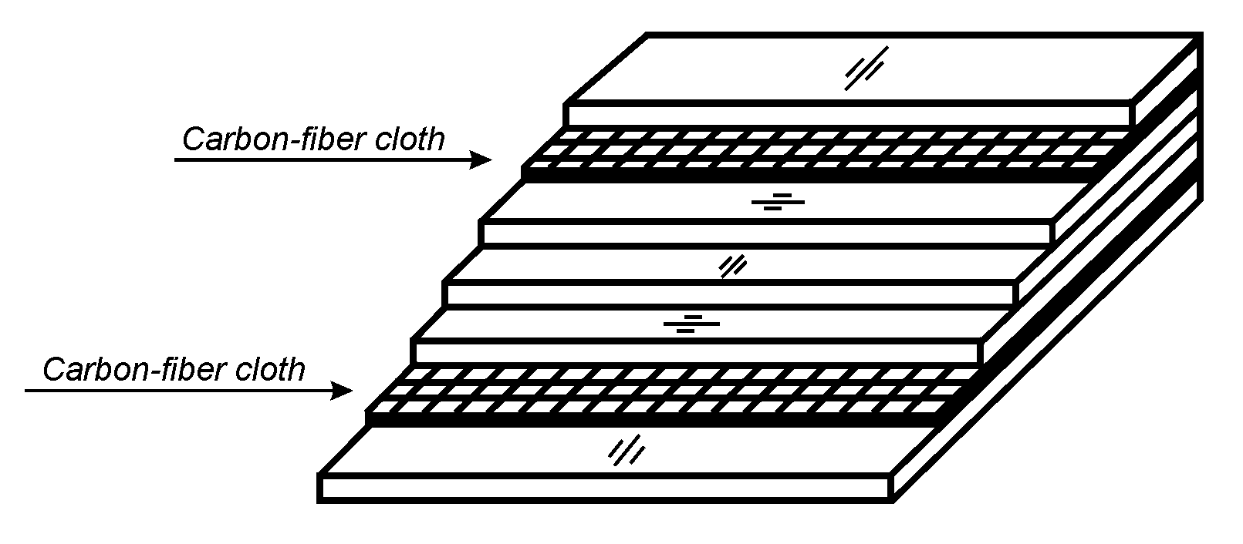

Figure 1 Construction of fibre reinforced plywood

Rotary cut poplarwood veneer having thickness of 2.2 mm and moisture content of 7% was used to produce plywood in the experiment. Veneer sheets were without defects to avoid their influence on the results of plywood testing.
Resorcine-phenol-formaldehyde resin was used as an adherent and impregnation means (LF 201 made by “Nafta” Lendava). Impregnation of carbon fibre cloth was carried out by use of a drum, containing 400 g/m² of resin. Recin recipe for impregnation and production of plywood was identical (100 parts of resorcine-phenol-formaldehyde resin, 8 parts of powdered paraformaldehyde). When gluing veneer to veneer, resorcine-phenol-formaldehyde resin was applied to each glueline at a spread rate of 220 g/m² and when gluing veneer to carbon fibre cloth it was spread at a rate of 200 g/m².
Plywood boards were hot-pressed at specific pressure of 1 MPa and temperature of 135 ºC. Pressing time was 10 minutes. After pressing, plywood boards were conditioned for six days, and the samples were cut for testing the required properties. Altogether, three boards were produced 600 by 600 mm in size.
In order to interprete properly the problem, the following properties were chosen and determined: bending strength along the grain of outside veneer, modulus of elasticity pursuant to HRN EN 310 standard and shear strength pursuant to HRN EN 314 standard.
The models were developed and analysed to provide better understanding of plywood behaviour during bending and to show the level of stress and deformations occurring in the used materials. The applied method was Finite Element Analysis (Cosmos/m 2.6 software).
In terms of dimensions and contour conditions, models corresponded to the actual test specimens used during bending strength determination (Fig. 2) so as to simulate as much as possible the actual testing conditions. Thus the results achieved by numerical method could be compared to the experiment results. Testing specimen models were defined as multilayer composite where each layer was divided in 400 finite elements.
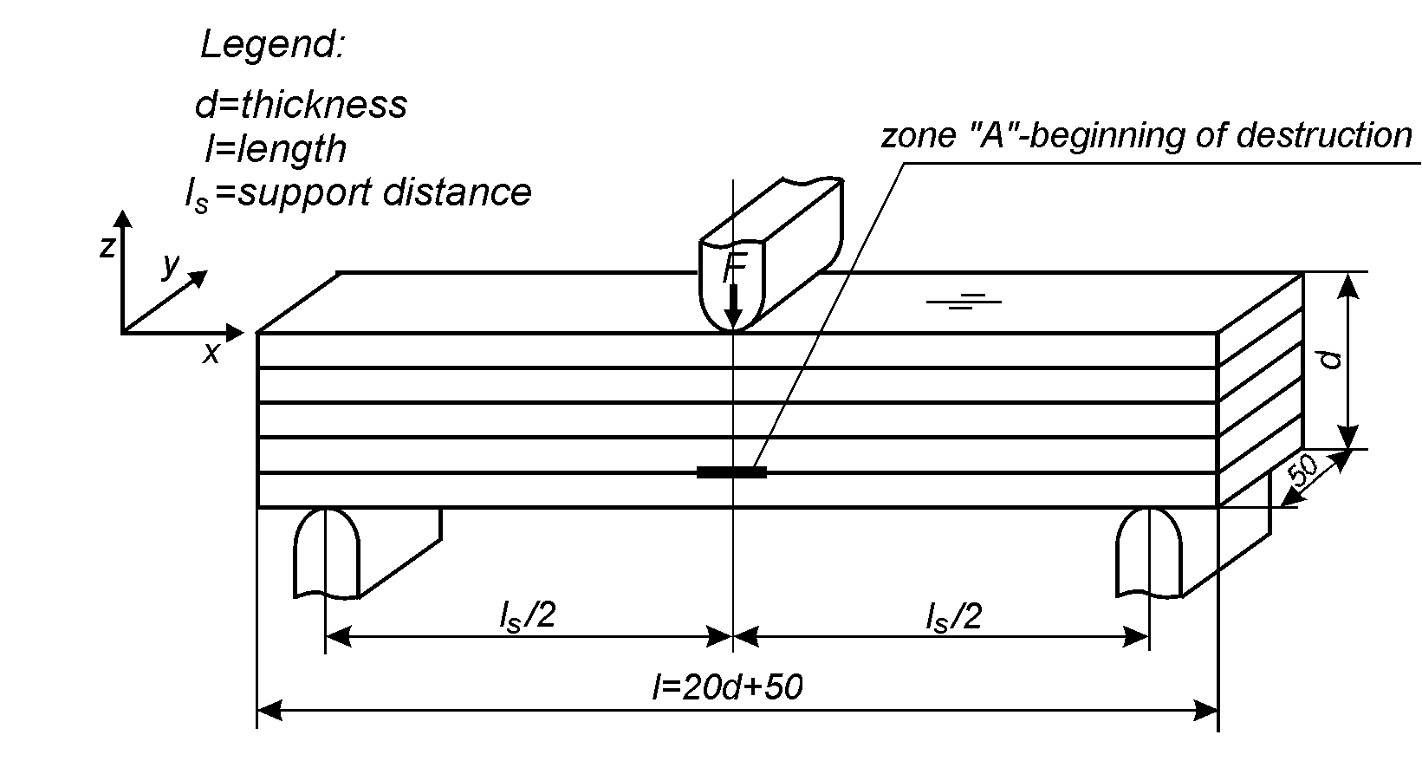
Figure 2 Plywood bending strength determination and model position in
co-ordinate system

Unlike the actual testing specimens, where bi-directional carbon fibres were inserted in plywood, with models this bi-directional layer was defined as two unidirectional carbon fibre layers interoriented perpendicularly (Fig. 3).

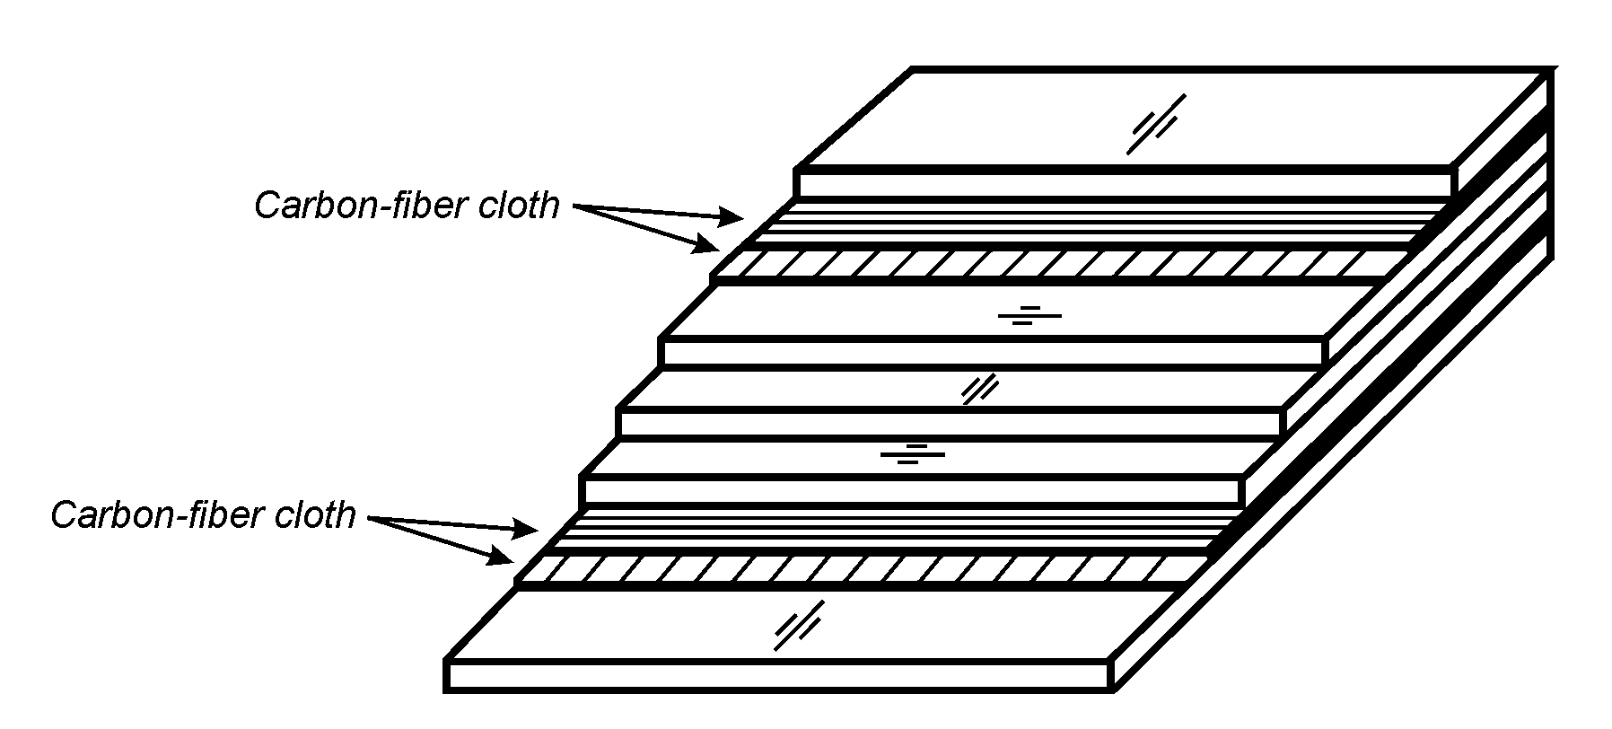
Figure 3 Principle of reinforced plywood model production

Carbon fibres and wood are defined as orthotropic material and hence for describing this kind of material, i.e. for defining material properties of the model, it is necessary to know their elastic properties. CADEC software was used for the determination of elastic properties and on the basis of fibres properties and matrix, the required elastic properties for one layer were calculated.
Veneer elastic properties and carbon fibre properties intended for defining model material properties are shown in Table 1.

Table 1: Material elastic properties
Modulus of elasticity (MPa) | Veneer | RC-12K | RC-3K
E_{x} | 9600 | 193350 | 168150
E_{y} | 420 | 3938 | 3928
E_{z} | 880 | 3938 | 3928
Shear modulus (MPa)
G_{xy} | 660 | 1080 | 1078
G_{xz} | 720 | 1080 | 1078
G_{yz} | 110 | 884 | 883
Poisson’s Ratio
ν_{xy} | 0.39 | 0.244 | 0.244
ν_{xz} | 0.32 | 0.244 | 0.244
ν_{yz} | 0.33 | 0.57 | 0.57
The directions of co-ordinate axes x, y, and z coincide with material carbon fibres axes x, y and z and veneer directions L (longitudinal), T (tangential) and R (radial).
Models are positioned in Cartesian co-ordinate system where the directions of co-ordinates coincide with three main directions of material axes, so that the ratio stress – strain can be shown (Barbero, 1999.):

$\left\{\begin{matrix}ε_{x} \\ ε_{y} \\ ε_{z} \\ γ_{\text{xy}} \\ γ_{\text{yz}} \\ γ_{\text{zx}}\end{matrix}\right\}=\left[\begin{matrix}\frac{1}{E_{x}} & −\frac{ν_{\text{xy}}}{E_{x}} & −\frac{ν_{\text{xz}}}{E_{x}} & 0 & 0 & 0 \\ −\frac{ν_{\text{xy}}}{E_{x}} & \frac{1}{E_{y}} & −\frac{ν_{\text{yz}}}{E_{y}} & 0 & 0 & 0 \\ −\frac{ν_{\text{xz}}}{E_{x}} & −\frac{ν_{\text{yz}}}{E_{y}} & \frac{1}{E_{z}} & 0 & 0 & 0 \\ 0 & 0 & 0 & \frac{1}{G_{\text{xy}}} & 0 & 0 \\ 0 & 0 & 0 & 0 & \frac{1}{G_{\text{yz}}} & 0 \\ 0 & 0 & 0 & 0 & 0 & \frac{1}{G_{\text{zx}}}\end{matrix}\right]\left\{\begin{matrix}σ_{x} \\ σ_{y} \\ σ_{z} \\ τ_{\text{xy}} \\ τ_{\text{yz}} \\ τ_{\text{zx}}\end{matrix}\right\}$ (1)

σ - stress and ε - strain in different directions, τ shear stress and γ shear strain in different plains.

The model was under load created by average force values, which caused the fracture of samples during bending strength determination. Thus the TP model (control plywood) was under the load of 1100 N, RC-12K model under 1540 N and RC-3K model under 1460 N.
Thus produced and defined models were used for carrying out statistical analysis and the achieved data were recorded. Stresses and the relative deformations were recorded for each layer of plywood. The deflection was also determined under the set load.

3. RESULTS AND DISCUSSION

The achieved testing results of experimental plywood are shown in Figure 4 to 7.

Figure 4 Thickness of experimental plywood

Figure 4 shows clearly that the use of carbon fibres as a reinforcer had small influence on thickness increase of plywood reinforced by carbon fibres.

Figure 5 Bending strength of experimental plywood

Figure 6 Modulus of elasticity of experimental plywood

Results gained by determination of bending properties (Fig. 5) and modulus of elasticity (Fig. 6) show great influence of carbon fibres on these characteristics of reinforced plywood. Bending strength parallel to grain increased by 30 to 40% in reinforced plywood compared to control plywood. When comparing the average values of bending strength between plywood RC-12K and RC-3K it can be seen that bending properties parallel to grain are slightly smaller in plywood marked as RC-3K. This fact will be explained through the analysis of models by Finite Element Method.
The testing results of reinforced plywood modulus of elasticity show that it is highly affected by the quantity of carbon fibres.

Figure 7 Shear strength of experimental plywood

All values gained by determination of shear strength in glueline (Fig. 7) for class 1 samples met the limit values specified by the standard (σ_{sm}> 1 MPa), considering the fact that the fracture mostly occurred in veneer layer during testing. The results of determination of shear strength will be used for expaining the results achieved by use of Finite Element Method.
The model analysis started with recording the stresses and deformations in each plywood layer. On that basis the intention was to determine the behaviour of reinforcer layer in view of different quantities of carbon fibres.
Distributions of values achieved in each plywood layer are shown in Figure 8 to 10.

Figure 8 Distribution of stress (a) and strain (b) in each layer in control board (TP) during bending

The graph shows clearly the influence of carbon fibres on the improvement of plywood bending properties.
With control plywood the outer sheets of veneer were subjected to the greatest stress and at the same time the distribution of both types of deformation (occurring in layers during bending) was linear (Fig. 8).

a)
b)

Figure 9 Distribution of stress (a) and strain (b) in each layer in reinforced plywood (RC-3K) during bending

a)
b)
Figure 10 Distribution of stress (a) and strain (b) in each layer in reinforced plywood (RC-12K) during bending

When observing reinforced plywood it can be clearly seen that carbon fibres as reinforcer take over a significant amount of stress and at the same time reduce the stress in veneer layers. It is obvious that under considerably higher stress, deformations in carbon fibres are significantly smaller than those in veneer. This can be explained by the fact that carbon fibres have better elastic properties than wood as well as a significantly higher breakage elongation.
Different values of stress and deformation have been recorded between plywood RC-3K and RC-12K both in carbon fibres and veneer. Larger quantity of fibres reduces stresses and deformations in veneer causing benefitial effect on bending properties of plywood.
Moreover, a higher quantity of fibres results in better solidification of plywood and accordingly the deflection in plywood RC-3K is 4.97 mm and in plywood RC-12K it is 3.54 mm.
All this explains why the modulus of elasticity is better in plywood RC-12 K but it remains unclear why the quantity of fibres has not such an influence on bending properties.
In testing bending strength of plywood RC-12K it was noticed that the delamination occurred in zone “A” (Fig. 2). At that position in the model, besides ordinary stress, records were also made of shear stress, which occurred in the material.
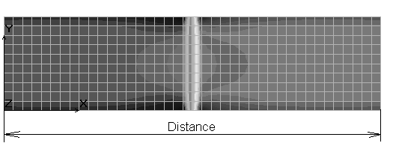
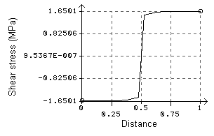

Figure 11 Distribution of shear stress in veneer layer

With control plywood, the highest value of shear stress was 1.65 MPa (Fig. 11), which is lower than shear strength achieved in the experiment. It can, therefore, be presumed that during testing of bending strength of these boards the fracture occurred only under influence of stress (compression and tension stress) and their relative deformations.
With model TP the veneer stress was 65.18 MPa, which is close to the value of bending strength achieved in the experiment.

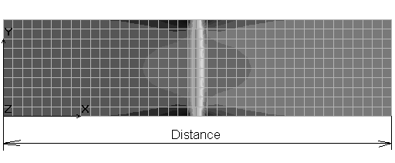
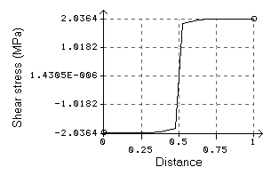
Figure 12 Distribution of shear stress in veneer layer in reinforced RC-3K plywood

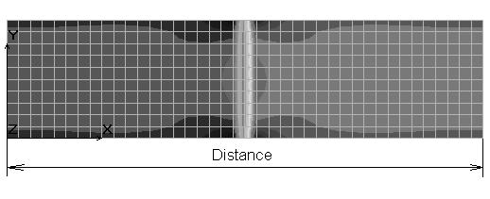
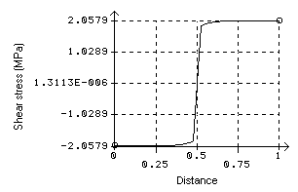
Figure 13 Distribution of shear stress in veneer layer in reinforced RC-12K plywood

In reinforced plywood it has been noticed that stresses in veneer are smaller than those in control plywood. But at the same time higher shear stress occurred in zone “A” and specifically for RC-3K boards it was 2.04 MPa (Fig. 12) and for RC-12K boards it was 2.06 MPa (figure 13). Maximum shear strength in experimental boards was about 1.90 MPa and the fracture occurred in veneer and hence it can be concluded that the beginning of destruction of reinforced plywood during bending strength testing was caused by high value of shear stress in veneer. This caused delamination in zone “A” and rapid impairment of uniformity and finally breakage of plywood. In both types of reinforced veneer plywood the value of shear stress was almost identical. On that basis, it can be presumed that in both types of reinforced veneer plywood, fracture occurred as the result of high value of shear stress in veneer. The only difference was that in RC-12K plywood it was more clearly visible.
This could have been caused by excessive difference between the properties of the used materials. In future researches, optimum ratio between reinforcer properties and properties of wood should be established so as to obtain the most favourable bending properties of reinforced product by their interaction.

4. CONCLUSION

On the basis of testing and analysis of all achieved results the following can be concluded:

- The use of carbon fibres causes significant increase of bending strength and modulus of elasticity if compared to control boards.
- The quantity of carbon fibres in reinforcer layer has influence on bending strength value but it is not significant, because the increase of fibre quantity is not followed by the adequate increase of bending strength.
- The influence is significant of the quantity of carbon fibres in reinforcer layer on the value of modulus of elasticity. Higher fibre quantity results in significant increase of modulus of elasticity, which implicates the use of reinforcer with higher fibre quantity in products where elastic properties are more important than strength.

5. REFERENCES

- Barbero, E.J. 1998: Introduction to Composite Materials Design.
- Brezović, M., Jambreković, V., Kljak, J. 2002: Utjecaj karbonskih vlakana na neka relevantna svojstva furnirskih ploča. Drvna industrija 53 (1): 23-31.
- Cook, R.D., Malkus, D.S.,Plesha, M.E., Witt, R.J. 2002: Concept and applications of finite element analysis. John Wiley & sons, inc., New York.
- Hughes, T.J.R. 2000: The finite element method-Linear static and dynamic finite element analysis. Dover publications, inc., New York
- Kollman, F.,Kuenzi, W.E., Stamm, 1975: Principles of wood science and technology I i II. Springer-Verlag, Berlin.
- Rowlands, R.E., Van Deweghe, R.P., Laufenberg, T.L., Krueger, G.P., 1986: Fiber-reinforced wood composites. Wood and Fiber Science (18)1: 39-57.
- Xu, H., Tanaka, C., Nakao, T., Joshinobu, M., Katayama, H., 1998: Effects of fiber length and orientation on elasticity of fiber-reinforced plywood.. Journal of Wood science (44): 343-347.

